

**Improve Coventry University Wayfinder Website**

**Navigation Page And Search Experience For Chinese International Student**

**Final Project Dissertation**



Author: Yisong Li

Student ID: 11384841

Course：Computer Science BSc(Hons)

Supervisor: Professor John Halloran

Submission time:11/04/2023

GitHub Link:

<https://github.coventry.ac.uk/liy332/Final_Project_ForntEnd_Yisong_Li.git>

<https://github.coventry.ac.uk/liy332/Final_Project_BackEnd_Yisong_Li.git>

**6001CEM Declaration of originality**  
**(This form should be completed by the student and included in the project report)**  
  
***I Declare that This project is all my own work and has not been copied in part or in whole from any other source except where duly acknowledged. As such, all use of previously published work (from books, journals, magazines, internet etc.) has been acknowledged by citation within the main report to an item in the References or Bibliography lists. I also agree that an electronic copy of this project may be stored and used for the purposes of plagiarism prevention and detection.***

**Statement of copyright**

I acknowledge that the copyright of this project report, and any product developed as part of the project, belong to Coventry University. Support, including funding, is available to commercialize products and services developed by staff and students.  Any revenue that is generated is split with the inventor/s of the product or service.  For further information, please see www.coventry.ac.uk/ipr or contact ipr@coventry.ac.uk.

**Statement of ethical engagement**  
  
I declare that a proposal for this project has been submitted to the Coventry University ethics monitoring website (https://ethics.coventry.ac.uk/) and that the application number is listed below (Note: Projects without an ethical application number will be rejected for marking).

Signed: Date:  
Electronic signature is acceptable  
  
Please complete all fields.



|  |  |
| --- | --- |
| First Name: | Yisong |
| Last Name: | Li |
| Student ID number | 11384841 |
| Ethics Application Number | P146134 |
| Supervisor | Dr. John Halloran |

This form must be completed, copied, or scanned and included with your project submission to Turnitin. Failure to append these declarations may result in your project being rejected for marking.

**Table of contents**

[Abstract 5](#_Toc25139)

[Chapter I: Introduction and Motivation 6](#_Toc19265)

[Chapter II: Literature review 7](#_Toc2932)

[1.Background 7](#_Toc13301)

[2.Understanding the Unique Needs of Chinese International Students: The Importance of Wayfinder 8](#_Toc11669)

[2.1Chinese International Students: Unique Concerns and Challenges in the UK Education System 8](#_Toc7157)

[2.2Improving Wayfinder Website For Chinese International Students At Coventry University: Importance And Implications 9](#_Toc24839)

[2.3Optimizing Wayfinder Websites Using UX design Methods -- Principles and Applications 10](#_Toc15217)

[3. Conclusion -- How to improve Wayfinder website effective 14](#_Toc24778)

[ChapterⅢ: Methodology 15](#_Toc32425)

[1. The choice of project design 15](#_Toc14396)

[2. Choice of technology 15](#_Toc23329)

[2.1 The choice of technology for user surveys 15](#_Toc10248)

[2.2 The choice of technology for data analysis 17](#_Toc29508)

[2.3The choice of technology for prototype design 18](#_Toc17323)

[2.4The choice of technology for software development 19](#_Toc9297)

[Chapter Ⅳ: The UX Design Process Of Coventry University Wayfinder Website 23](#_Toc5182)

[1. Preliminary user survey and data analysis 23](#_Toc14474)

[1.1 Pre-visiting for Chinese international student 23](#_Toc12892)

[1.2 Questionnaire Design -- To Enhance CU Wayfinder Webpage Use by CIS 24](#_Toc2040)

[1.3 Data Analysis of the Questionnaire on Chinese Students’ UX and Satisfaction with Wayfinder 26](#_Toc6233)

[1.4 Face-to-face interview: Chinese students share their views on Wayfinder website 33](#_Toc25674)

[2. Prototyping development 34](#_Toc14125)

[2.1 Wayinfer home page design 34](#_Toc20622)

[2.2 Information plate page 36](#_Toc27584)

[2.3 Tuition inquiry preparation page 39](#_Toc19417)

[2.4Tuition Inquiry Page 41](#_Toc8051)

[Chapter Ⅴ: The Software Development Process Of Coventry University Wayfinder Website 43](#_Toc28191)

[1.Front-end development ideas 43](#_Toc30240)

[2. Backend development ideas 44](#_Toc20672)

[3.Important components developed for the first time 45](#_Toc15588)

[3.1The search box 45](#_Toc18590)

[3.2 Paging components 46](#_Toc10351)

[3.3 Prepare the tuition inquiry page -- Button function 47](#_Toc26034)

[3.4 Query Tuition page - search box 51](#_Toc9909)

[3.5 Query tuition page - Text search box 55](#_Toc3195)

[3.6 Query tuition page -- Database visualization 57](#_Toc26411)

[4. Important components of the second development 61](#_Toc24513)

[4.1 Fuzzy search for infoboxes 62](#_Toc5631)

[4.2 Search the records bar 64](#_Toc9591)

[4.3 Error Return popup 66](#_Toc27107)

[4.4 Breadcrumbs path 69](#_Toc26577)

[4.5 A-Z sort the specialty names 71](#_Toc24935)

[4.6 Search the discipline code in the search box 72](#_Toc23480)

[Chapter Ⅵ: Discuss current and future value --- improving the Coventry University Wayfinder website 74](#_Toc13305)

[1. Discuss the value of the current work 74](#_Toc8268)

[2. Discuss the future value of current work 74](#_Toc23550)

[3. Discuss the issues need to be considered 75](#_Toc18200)

[3.1 The problem in this project 75](#_Toc2726)

[3.2 Based on wider Wayfinder usage 75](#_Toc21271)

[Chapter Ⅶ: Deliverables 76](#_Toc7014)

[1. Wayfinder website project 76](#_Toc3267)

[Chapter Ⅷ: Conclusion 79](#_Toc3134)

[Chapter Ⅸ： Project Management 81](#_Toc15301)

[1. Project aim and objectives 81](#_Toc26935)

[2. Current project completion 81](#_Toc6913)

[3. The technologies and tools involved in the project 82](#_Toc19638)

[4. Project Planning 82](#_Toc16907)

[5. Meetings with supervisors and evidence of supervision 84](#_Toc25504)

[6. Evidence of the content of my project 86](#_Toc22352)

[7. The project explores social, professional, legal and ethical issues 87](#_Toc7011)

[8. Project risk management 88](#_Toc14452)

[9. The future work of my project 89](#_Toc4434)

[10. Power Point screenshot: 89](#_Toc29366)

[Chapter Ⅹ: Acknowledgement 92](#_Toc22020)

[Chapter Ⅺ: Reference 93](#_Toc29526)

# Abstract

In recent years, the number of Chinese students studying in the UK has been increasing year by year -- Coventry University, in particular, has become a popular choice for international students from China. How to improve the experience of Chinese students has become a hot topic today.

Coventry University's Wayfinder website is dedicated to providing students with information on and off campus and is indispensable for many Chinese international students at Coventry University.

Through the daily communication with some Chinese students studying abroad at Coventry University, it is found that there are still many problems with Wayfinder's website at present, so it is significant to explore and solve the existing problems from the perspective of actual users.

In this dissertation, the practical value of the Coventry University Wayfinder website will be discussed in detail, and Chinese students will be communicated through questionnaires/interviews to explore and collect the concerns of existing/actual users. Furthermore, through user feedback, using various technical methods to improve Wayfinder's existing problems and implementation.

Through these explorations and practices, the Wayfinder website can be used to improve the experience of Chinese international students while improving their satisfaction with the daily study of Coventry University. Not only that, but it also provides a useful example for other UK institutions of higher learning to improve the experience of international students.

# Chapter I: Introduction and Motivation

With the development of The Times, more and more students from all over the world come to Britain for higher education -- especially international students from China. There is a big gap between the Chinese and Western education models because of regional differences. By comparing the differences between Chinese and Western education, I find that the western mode of higher education gives students significant autonomy, emphasizes that students should act as an "individual" in the university, and requires students to adapt to the information of exploration in the unknown field. While China's higher education is collaborative teaching, students in the university are more 'passive education' - including academic/life /etc. issues. Students can ask their supervisor/counsellor for answers if they have any questions. (Yijiao Qi & Qiong xie, 2018) As a result, many overseas students from China have faced a lot of daily life/academic 'maladjustment' problems.

However, most UK universities now have support centres and other departments to help international students - including telephone/face-to-face meetings. However, a survey found that the vast majority of Chinese students studying abroad avoid direct communication with native English speakers -- including university staff -- as much as possible because of language problems and a sense of 'community'. At Coventry University, a Wayfinder website allows students to find information on their own - an excellent way to avoid direct communication with others (China Youth Daily, 2016). However, in the daily communication with my Chinese friends studying at Coventry University, I found that some students still have opinions on Wayfinder and have a bad experience in using Wayfinder website.

In response, I became interested in how to improve Wayfinder. In this regard, I decided to start with the actual users, find out the needs of users through investigation and data sorting, determine the modification plan, and implement it with various code technologies. Through the improvement of the Wayfinder website, from the technical level and immediate sense, the user experience of Chinese international students can be well improved, and the satisfaction of Chinese international students studying in the UK can be enhanced. Moreover, by digging into the actual problems of Wayfinder and starting from the perspective of Chinese students studying in the UK, we can better explore the problems that Chinese students are faced with/concerned about during their study in the UK, help Chinese students from the root cause, and enable them to adapt to and integrate into the local/school learning faster.

Therefore, in this project, my aim is to improve the experience of Chinese international students studying in the UK while improving the use experience of Wayfinder through a survey of Chinese international students. The objectives is to complete the UI/ function design of Wayfinder's homepage and function pages, and improve the use process of tuition inquiry.

# Chapter II: Literature review

## 1.Background

In today's "global village" society, every country in the world has become more closely connected -- from the flow of goods to regional cultural exchanges. At the same time, due to the history and regional economic/education gap in different regions, more and more students go to other countries to study for better higher education resources. the share of international students from China has risen considerably in the past decade. According to data from HESA (*Higher education student statistics: UK, 2020/21 - where students come from and go to study | HESA.* 2022), from 2016 to 2020, the number of international students from China increased by as much as 50%, reaching over 140,000, making it the largest number of study-abroad departures in non-EU regions.

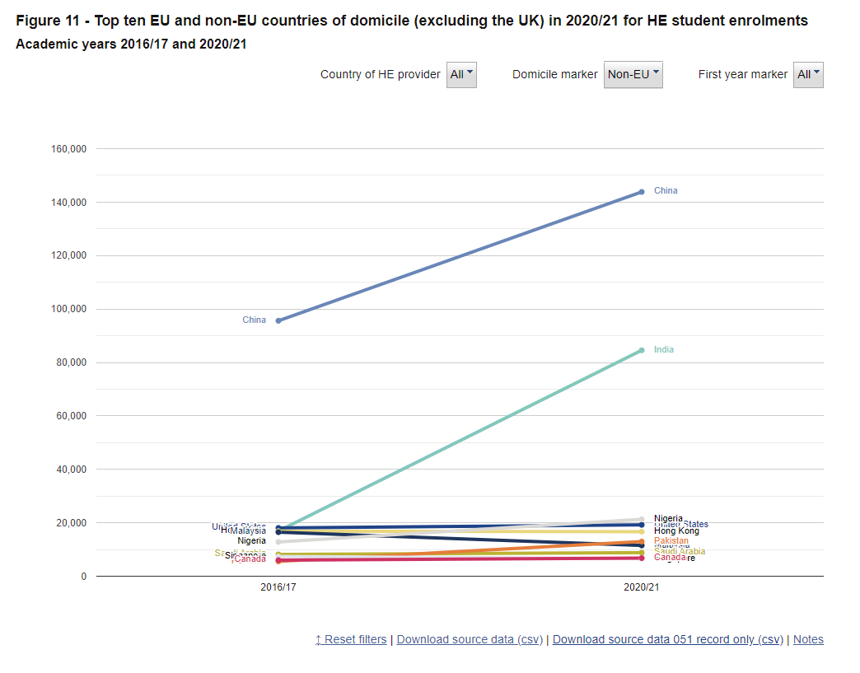

(Figure1 – screenshot from HESA)

So, at a time when the number of international students in the UK is increasing -- and Chinese international students constitute a significant part of the population, we need to pay more attention to the problems faced by this whole group. According to Mary sherry's research (Sherry et al., 2010), the main issues faced by international students around the world are language, life and finance. The existence of these problems will significantly affect the experience of international students. Therefore, how to effectively help international students to solve these problems and improve international students' experience of studying abroad has become an issue that education departments need to focus on.

Fortunately, Coventry University in the UK design a Wayfinder , an information query software, in order to improve the experience of students. Students can inquire about school/life issues through the website. To a certain extent, this software solves the problem of overseas students' inquiry and consultation and solves the issues that international students may encounter in campus life. However, in the daily conversations with Chinese international students, it is found that a large number of students still have some opinions on the experience of using the website, mainly dissatisfaction with the experience of the information search process.

## 2.Understanding the Unique Needs of Chinese International Students: The Importance of Wayfinder

### 2.1Chinese International Students: Unique Concerns and Challenges in the UK Education System

According to the research and survey of relevant scholars (Ammigan & Jones, 2018), it is found that most British international students focus on the following aspects

1. First-night stay

2. Lecture quality

3. Accommodation quality

4. Campus meal options

Of course, these issues are indeed the focus of international students. However, when it comes to Chinese students, that is not enough to cover the real concerns of Chinese students. Studies have shown that Chinese students are more inclined to lecturers. Because of the academic authority and personal wisdom of lecturers, Chinese students are more inclined to rely on the assistance of lecturers. This reflects a problem. British universities and other departments continue to launch activities or information releases to promote international students, but many Chinese international students rarely participate. In addition, some studies have shown that Chinese students go abroad (Counsell, 2011) partly due to the shortage of teaching resources in mainland China and the fierce competition in the job market. Therefore, the primary concern of most students studying in the UK is how to obtain campus resources more efficiently and improve the quality of campus life. However, because the two countries' education systems are different, it could be more systematic in the UK - a class-centred education system. On the one hand, the British education system provides individuals with a vast space for free development, allowing them to develop their potential better. However, on the other hand, this model makes Chinese students not have a correct and convenient channel to obtain influential information-although. British universities and other departments have already released information on various social media-but too much Verbosity is challenging to acquire. Through this consideration, it has also been very significant to reflect a critical ''' blank field'' in enhancing the experience of Chinese international students.

### 2.2 Improving Wayfinder Website For Chinese International Students At Coventry University: Importance And Implications

To address the international student experience, Coventry University offers Wayfinder, a campus/information search system, which provides a platform for international students studying at Coventry University to find basic information. In this system, we can inquire about tuition and how to apply for a campus card. However, its interface design, support features, and search experience could be improved. According to the survey (Ammigan & Jones, 2018), British students in the UK are most worried about their economic situation before coming to the UK; After three months of study, finances were the biggest worry for most students (59%), followed by food (32 %) and loneliness (30 %). In Wayfinder's interface, more queries only contain relevant information within the school. The query process needs to be simplified, which significantly reduces the experience of first-year students and seniors. As a platform to support information inquiry, it plays the role of "head teacher/mentor" from the perspective of Chinese students. Some studies show (Ammigan & Jones, 2018; Schweisfurth & Gu, 2009) that the experience of international students can be significantly enhanced if students better organize and manage their study time, broadening their life experience and interests.

In response, Coventry University has also launched Nova, Solar and other online pages to help students use academic information search software, including but not limited to grades/attendance. However, most are fragmented/not easy to find. So Wayfinder's role is not just an "answer" finder but a "way" finder. Giving Wayfinder more capabilities as a comprehensive resource search platform will significantly increase Wayfinder's overall usage.

This change could strengthen the relationship between other/UK educational institutions and Chinese international students. Through the use of the integrated navigation system, Chinese students can clearly understand the concerns of students and strengthen their attention so that students can feel that they are part of the "collective" and that students/international students can experience the psychological support of the powerful information function of the school even far away from home. Moreover, according to the above research on Chinese international students, this self-inquiry system can effectively avoid the incompatibility between Chinese students and native English speakers (school staff/classmates) to relieve the psychological pressure on Chinese students and improve the experience of Chinese students in the UK.

### 2.3 Optimizing Wayfinder Websites Using UX design Methods -- Principles and Applications

**2.3.1 Why Use UX design to improve Wayfinder Websites - How UX design Works**

When it comes to improving the experience of using a website, there are often multiple ways to do this -- e.g. A/B testing, social media feedback, using usability evaluations, using emotional design, etc. But UX disign would be better for this project in comparison. But why is UX disign better? How does UX disgn work? We will explore the benefits of UX disgn by examining its principles and methods.

Within the specifications of UX design, there are many design principles. In improving applications with ux design, the most famous are Norman's Principles (Fleming & Koman, 1998)/ Nielsen heuristics (Nielsen, 1995)/ Tog's First principles of interaction design (Tognazzini, 2014)/ Petrie and Power (Petrie & Power, 2012), etc. These principles are invariably based on user psychology, product function design, and the relationship between the two. With a thorough understanding of these principles, UX design principles can be divided into three parts ---- Availability, Visibility, and Affordance.

1. Usability refers to how the target product feels to the user, focusing on how convenient/efficient/intuitive the user feels when using the product. It includes memorability, efficiency, practicality, fault tolerance, measurability and ease of use. Usability emphasizes the ability of users to complete tasks successfully.
2. Visibility refers to user interface design, where a page contains functions and controls that are obvious to the user and easy to find and use. It includes physical button visibility, current state visibility, and step visibility. Visibility emphasizes the user's ability to understand the system's state and feedback clearly.
3. Affordance refers to the possibility of action provided by the environment for people. It is like a power hidden behind the design to promote the interaction between people and objects. It includes supply presence, supply perception, supply realization and supply effect. Affordance emphasizes the ability of the user to perceive the behavioural possibilities provided by the object and to use it to achieve the behaviour that supports the goal.

After exploring the principles of UX design, we found that UX design can better consider the user's thoughts and achieve a "people first" design philosophy. So, what are the specific methods and processes of UX design? We will continue to explore.

Based on UX design principles, we can divide UX design methods and processes into the following stages through data investigation and summary.(Almeida & Monteiro, 2017; Gray, 2016).

1. **User research**: By surveying target users to understand their needs, behaviors and attitudes, find out the real problems.
2. **Information architecture design**: According to the needs of users and information structure, design information classification, organization and labeling, so as to facilitate users to find information.
3. **Interaction design**: Design the interaction and feedback between users and the system to improve user experience.
4. **Prototyping**: Using simple models or prototypes to quickly implement initial ideas, identify and solve problems.
5. **Usability testing**: Involve users in product testing, evaluate the system's usability and user satisfaction, and make improvements based on the results.
6. **Visual design**: Design the user interface based on the user experience, including styles such as appearance, graphics, functional layout, and font colors.
7. **User test**: After product completion, select some user test products to know whether there are improvements to the interface, functions, components, as well as the effect of experience and customer satisfaction, and make further improvements according to the analysis.

These stages constitute the complete flow of UX design to create products with meaningful and relevant user experiences.

**2.3.2 UX design classic case and example**

In various fields today, many companies are also using UX design to improve their products. For example, Apple uses heat maps and user research to improve its website and ios system and gets good user feedback (Apple’s website: Comprehensive analysis of the UX design with heatmaps. 2021). Or Airbnb updated the components and UI of the app according to users' feedback in the system, combined with the general environment of the epidemic in 2021, and received high praise from users (Gaster, 2021).

Similarly, there are many examples of how UX disgn is used in education to improve the student experience, and we'll explore a few classic examples below.

1. **STMIK Rosma University improve student complaint process**

STMIK Rosma University (SRU) from Indonesia is faced with the problem that the process of student complaints needs to be more effective and standardized enough, those student complaints should be handled and recorded promptly, and the situation of complaints should be monitored and resolved. The SRU decided to use UX design based on student feedback to solve this problem. They divide the solution process into four stages: empathy, definition, creativity, and prototyping.

(Setiyani & Tjandra, 2022)

In the first stage, the school surveyed students and relevant school staff through observation and interviews and found that the current student complaint process is still manual.

In the second stage, by collecting and sorting out students' feedback questions, the school drew a flow chart of the current student complaint process. It carried out a specific analysis of the current problems to determine the causes of each issue and better understand the problems encountered by different departments.

In the third stage, the school ranked the problems, analyzed the solutions, and identified the business processes and specific functions/components to improve the complaint application.

In the fourth stage, the school designed a prototype UI/UX application based on SketchUp, summarized above to deal with student complaints, including specific components/ICONS/fonts, etc.. It drew conclusions based on the actual problems.

Finally, the SRU uses UX design techniques to improve the current problem and successfully enhance the student experience.

1. **UK universities and education departments use UX design work and results**

In the UK, there are also a number of educational institutions and universities using UX disgn to improve the student experience

* + **University of Sheffield**

The University of Sheffield has launched iSheffield (The University of Sheffield, ). This app connects international and domestic students for cultural exchanges and social activities to get international students involved on campus. The app has been designed with national and international student input in mind to ensure it meets their needs. iSheffield's web page, for example, has features such as campus maps/job Search services - which, although available to all students, make it somewhat easier for international students to work in this field.

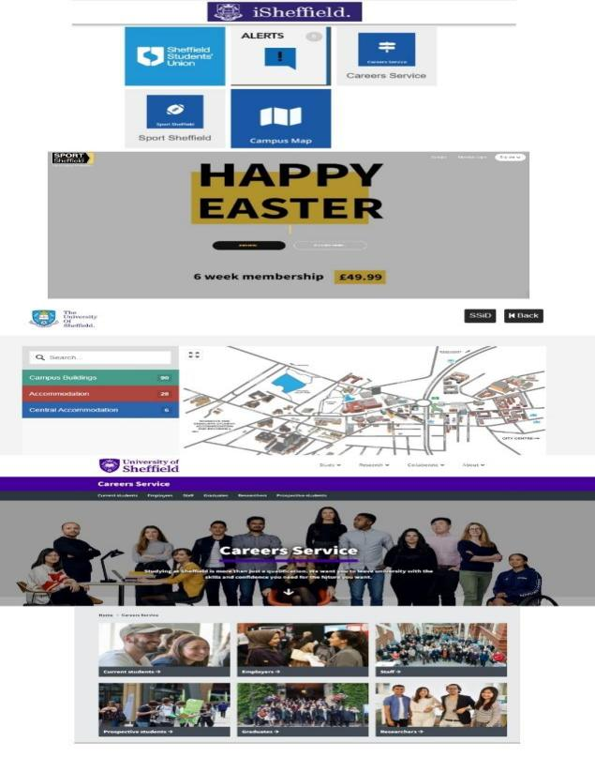

(Figure2 – iSheffield from Sheffield Uni) (The University of Sheffield, )

* + Imperial College London

Imperial College London is using UX design to improve its international student recruitment process in order to better serve international students (*International student | imperial college london.* ). They have created a new website to provide international students with clear information about the application process, admission requirements and other important topics. The site is visually appealing and easy to navigate, making it more friendly for international students. For example, the website contains information services for international students -- information on visa immigration/support for international students. The provision of such information makes it easier for overseas students to find information and increase their satisfaction and experience during their study abroad.

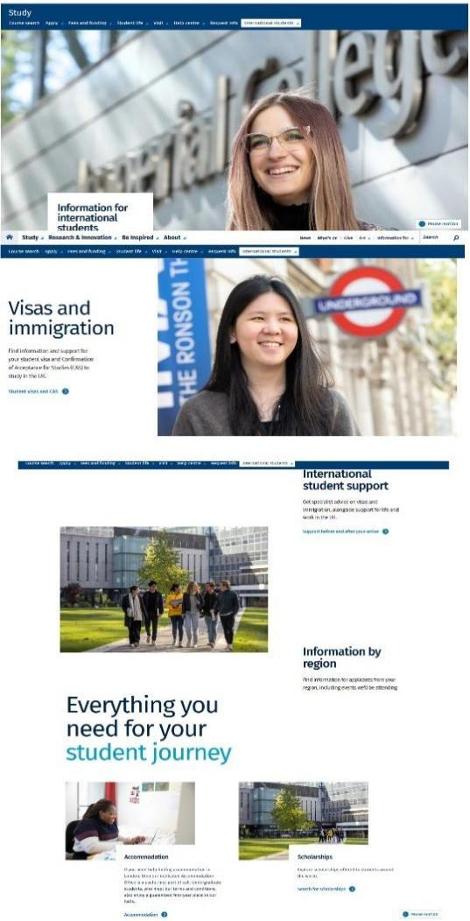

(Figure3 – International student page from IC Uni) (*International student | imperial college london.* ; The University of Sheffield, )

## Conclusion -- How to improve Wayfinder website effective

By learning UX design methods/principles and cases, we find that UX design can better understand the needs of users and design applications (products) from the perspective of users. We have also found that using UX design to enhance the student experience is the best choice. In the design, we should pay more attention to the actual problems users face, transform user needs into practical UI/ functions, and try our best to solve users' difficulties. Based on this, the project will establish a UX design approach to improve Wayfinder and a "user-centric" design philosophy to establish a research project process to improve the Coventry University Wayfinder experience of Chinese students using.

# ChapterⅢ: Methodology

## The choice of project design

In this project, we decided to use UX design to improve Coventry University Wayfinder -- by making the design more user-centric. At the same time, through the literature review analysis, we established three principles of Availability, Visibility and Affordance for design. It is committed to providing users with a better page experience. All the functions are prominent and easy to find, improve users' efficiency in using Wayfinder, and enable users to solve problems quickly. In the design process, we have established six parts as the UX design project process: user survey -- data analysis -- prototype design -- web development -- user survey -- web redevelopment. Through the composition of six parts, we can better understand the needs of users and then better meet the needs of users.

## Choice of technology

In this project, many technologies will be designed. Therefore, we divided this project into four parts -- user survey, data analysis, prototype design, software development, and technology selection respectively

### 2.1 The choice of technology for user surveys

In user project surveys, different survey techniques are mainly used to collect users' needs and current problems, conducive to rapid problem positioning and clear research objectives, laying a solid foundation for subsequent investigation.

In this section, we can choose to use the following techniques.

* interview
* observe
* questionnaire
* visit
* A/B testing
* Card sorting
* Usability testing

After comparing the methods of this project, I choose three methods -- interview, questionnaire survey and interview.

**1)Preliminary investigation – Visit**

When a project idea is born, visiting the target users and asking for their opinions is the best way to determine whether the research project needs to be innovative. In the process of interviewing multiple users, you can get a clearer idea of the current problem. In the dialogue process, empathy can better understand the needs of the target user, understand the pain points of the user without disturbing the user's situation, and determine a good direction for future research projects.

**2) Interim survey -- Questionnaire**

In UX design, questionnaires are the most common form of survey. A well-constructed questionnaire can quickly and immediately evaluate software products, obtain users' satisfaction with the product and reflect the existing problems of the product (Erdős, 2019). Moreover, the questionnaire can be constructed to understand the properties of the current product better and provide data support for future research/improvement direction.

When compiling a questionnaire, it is necessary to follow the rules of the questionnaire - relevance/no dependability/no user memory bias. At the same time, questionnaires have many different questions- single choice/multiple choice and so on. In preparing this questionnaire, I chose "single choice + multiple choice + rating + short answer". Through this design, I tested the interviewees from multiple dimensions and gave them more flexible space to answer to obtain better the information obtained.

**3) Later investigation – Interview**

The interview based on the questionnaire survey can conduct a more in-depth study on the problems existing in the current products. According to the results of the study directed (questionnaire), the interview of the target respondents can effectively obtain personal opinions based on the results of the questionnaire, more specifically, locate the scene and reason for the current problems so that the improver can better understand the current issues (Kollmann et al., 2009), and is conducive to the subsequent work of improving the product.

**4) Secondary studies -- Literature review(special)**

In the first three methods, we can define it as preliminary research. But in the study of the current literature, we can do a secondary study - that is, the problems that have been found/exist. In the fourth part of the literature review in this report, this research is carried out.

### 2.2 The choice of technology for data analysis

Data collection and processing is essential to the UX design process. Good data collection and survey can help designers better analyze problems and guide them to effectively design products to improve user experience. In this project, we will use the questionnaire system from China, sojump(WenquanXing) (*Sojump.* ), to collect and analyze users' data.

sojump is an online questionnaire survey system in China, similar to Goggle form. The site offers custom editing questions and offers a variety of formats - single/multiple, etc. After the questionnaire is released, the system will automatically collect the data filled in by the visitors, make automatic data statistics, and present the proportion of data in various forms (including line chart, bar chart, pie chart, etc.), which can reduce the use of Excel tables for data comparison in the later period, obtain data visualization more intuitively, and improve research efficiency. In addition, the platform also provides a variety of data analysis technology support (SPSS, personalized data analysis, etc.), in-depth data analysis.

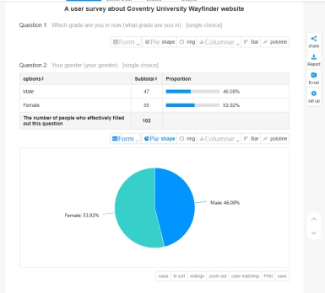

( Figure4 – sojump supports graphic analysis capabilities)

In this research project, the object of our study is Chinese international students. Studies have shown that Chinese students use Chinese social media -- not the mainstream ones (Facebook/Instragram, etc.) -- a lot when they are abroad (Li & Chen, 2014). sojump platform, however, supports the scanning of the code to answer the questionnaire on wechat (a Chinese social platform), which to some extent makes Chinese international students more active in participating in the questionnaire and optimizes the experience of the questionnaire participants, which is in line with the user-centered optimization design concept in UX design.

### 2.3The choice of technology for prototype design

Prototype design -- Based on the results of data analysis, quickly implement the product prototype, so as to quickly discover the problem. In UX design prototypes, there are two types of design: non-interactive/interactive design.

* Non-interactive design, which refers to static/non-interactive prototypes, is usually worth showing simple wireframes or still images.
* Interaction design refers to the interaction between functional components in all prototypes to simulate the real interaction process between users and products.

The main difference is that non-interactive design focuses on the conditions and rules that show the design -- such as a new UI/ component design for a web page. While interaction design focuses on the rules that show up in the prototype design -- simulating the actual interaction between the product and the user without the current improved product.

In this research project, interaction design is chosen as the design type of this prototype. First of all, using interaction design to complete the prototype design drawing of the website can make the target users better understand the function and use of the product, and let users better feel the interactive experience of the product. Not only that, designing prototype diagrams can quickly let users experience the interaction of prototypes, and carry out code implementation more effectively.

### 2.4The choice of technology for software development

In this software development part, mainly is the prototype diagram for code implementation.

In the choice of development framework, there are several common frameworks are the most common.

I used Java as the main language, used Vue framework at the front end and Spring boot at the back end, and carried out construction in the mode of separating the front end from the back end

* **Front-end technology selection -- Vue farmwork**

Besides using Html+css and other languages in the front-end design, I also adopted Vue as the front-end framework. Vue is not only a framework but also an ecology. It meets the most common requirements for front-end development. But the Web world is very diverse, and Web products built by different developers can come in all shapes and sizes. As a result, Vue is designed with a strong emphasis on flexibility and "can be integrated progressively."

Currently, the Vue framework can be used in the following scenarios:

1. Incremental enhancement of static HTML without building steps
2. Embed as Web Components in any page
3. Single page application (SPA)
4. Full stack/server rendering (SSR)
5. Jamstack/Static Site Generation (SSG)
6. Develop interfaces on the desktop, mobile, WebGL, and even command line terminals

At the same time, React is also a very popular front-end framework, but why I choose Vue as a front-end framework can be analyzed through the following comparison (*Differences between vue and react.* 2022; Hongyang Wang, 2016; Levlin, 2020; Rawat & Mahajan, 2020; Saks, 2019).

|  |  |  |
| --- | --- | --- |
|  | VUE | React |
| Component reference | There are global registration and local registration | The corresponding component is imported and then referenced in the template |
| Data stream | 1. The parent component updates the child component view by passing props, explicitly calling the props option to declare what data it expects.  2.vue is mutable, two-way binding, declarative, horizontal splitting of vue components often uses mixins. | 1. It's officially recommended that props correspond to input and output like pure functions, and it's not recommended that you use props to change views.  2.react is the whole idea is functional, so it promotes pure components, immutable data, one-way data flow, of course, two-way can also be done, such as combined with redux-form, the horizontal split of components is generally through higher-order components |
| Template | 1.Templates group html, css, and js together in their own way.  2.vue has single-file components, which can write html, css, and js into a single file. html provides a templating engine to handle that. | 1. All in js, js to generate html, so designed jsx, and js to manipulate css, community styled-component, js, etc. |
| Events | 1. Each Vue instance implements an event interface to communicate with parent and child components. There is no need to introduce state management in small projects.  2.Vue adds computed and watch. | 1. You have to implement your own events.  2. You can only write a logic using JSX syntax. |
| State management | 1. The state object is not required, the data is managed in the Vue object by the data property.  2. Refer to vuex for state management when non-parent and child components are nested too deeply. | 1.It's a key concept in react. It's immutable. In React you need to use setState() method to update the state.  2. Refer to react-redux for state management when non-parent and child components are nested too deeply. |
| Learning curve | 1.The learning curve is easy, and there's a lot of syntactic sugar inside | 1. The learning curve is slightly more complex and flexible |

So, Vue is much more flexible and easy to write than React, making it easier to implement in this website implement.

* **Backend technology choice – Spring boot**

Spring boot is a great back-end design language, but first you need to understand what the Spring framework is.

At present, the Spring framework is the most widely used framework in Java program development scenario. Its success comes from the idea, not the technology itself, its ideas include IOC (Inversion of Control) and AOP(Aspect Oriented Programming). The Spring framework is a layered architecture that consists of five major components:

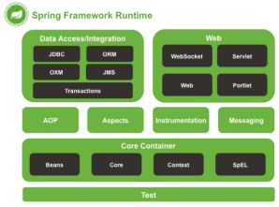

(Figure5 -- Spring Architecture Diagram) (*Spring.* 2020)

1) **Core Container:** It is used to provide the basic functions of the spring framework. It realizes the management of the life cycle of objects and the decoupling between objects through IOC.

2) **AOP:** the concrete implementation of Aspect-oriented programming. Decoupling between component codes is realized.

3) **WEB**: used for the realization of web development functions, MVC function realization, etc.

4) **Data Access:** database operation module, mainly realizes transaction management, ORM support, JDBC encapsulation, etc

5) **Test:** Used for unit testing of the project, providing JUNIT test support.

For this backend, SpringBoot is based on Spring, and it has been extended and improved according to the idea of "habit is better than oh." (NagasakiAtomicBomb, 2020) It inherits from Spring and allows Spring to auto-configure. Spring Boot has changed that, making it possible to create a Web development project in just a minute. With Starter, we can easily integrate third-party frameworks without XML configuration, just annotations and properties files. In addition, Spring Boot Starter can reduce the jar dependency, import a Starter, set some property values, and complete the integration process (*How to understand that conventions in SpringBoot are better than configuration.* 2019).

At the same time, backend development with Spring boot can be summarized as the following advantages (Cynical Gary, 2020; Ziwoi, 2019):

1.It's easier to develop Web applications with Spring.

2. Annotation-based configuration avoids writing a lot of repeated XML configuration.

3. No configuration and no code generation for XML.

4, provide embedded server, make the development and deployment become very convenient.

Therefore, using Spring boot for the backend made it much faster to build this project, reduced development time, and easier to code.

* **Front-end technology combination - Vue+Springboot**

So, in this project, we implemented a front-end separation and used the Spring Boot + Vue stack to build the website. The advantage of this pattern is that the front-end communication uses the standard JSON format to interact, and the back-end only needs to provide the JSON data needed by the front-end page. Front-end developers can independently write client-side code and make Ajax requests to the back-end data interface to display the data on the page. The front end can set up some fake data for testing, do not need to rely on the back end at all, and finally complete the front and back end integration. This mode really decouples the front-end and back-end applications, which greatly improves the development efficiency (Ziwoi, 2019).

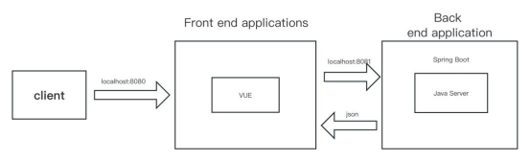

(Figure6 -- The overall framework of the program)

# Chapter Ⅳ: The UX Design Process Of Coventry University Wayfinder Website

## Preliminary user survey and data analysis

Through communication with Chinese students in the UK, we found many Chinese students are dissatisfied with the Wayfinder website in Coventry. In this regard, we used UX design to improve Wayfinder. This part will cover the preliminary user investigation to the prototyping part and will discuss the details of the research process and the design principles in detail.

### 1.1 Pre-visiting for Chinese international student

Chinese students studying in the UK face many challenges, including finding the correct academic information and convenient life services in an unfamiliar environment. To help these students adjust to life in the UK, Coventry University (CU) has launched the Wayfinder web page with various helpful information and resources. However, in my daily conversations and daily life exchanges with 15 Chinese international students in the Department of Computer Science at Coventry University over the past year, I found a surprising fact: most Chinese International Students (CIS) are confused and complain about the current Wayfinder web page—for example, In my interview, Junpeng. Z, a computer science student at CU, once said, "The Wayfinder of Coventry University made my overseas study experience worse. Although Wayfinder can help me solve some problems, such as academic/life problems, I still find Wayfinder difficult to use.". After recalling what had been said in past conversations, they reported the following problems with the page.

* Wayfinder web page layout can be more coherent, navigation can be more straightforward, and it isn't easy to find the desired content.
* Wayfinder's web content is too straightforward and lacks consideration of the unique needs and cultural differences of Chinese (international) students.
* The web page is less interactive, and the user experience in feedback and operation could be better.

These issues affected Chinese students' experience using the Wayfinder web page, their satisfaction with Coventry University and their experience living in the UK. Therefore, improving the Wayfinder webpage was necessary to improve the user experience (UX) design of the Coventry University Wayfinder website. User experience design refers to "building products that are easy to use and enjoyable". Through user experience design, we can better improve the Chinese students' experience of using the Wayfinder website and help Chinese international students in the UK quickly adapt to life in the UK.

### 1.2 Questionnaire Design -- To Enhance CU Wayfinder Webpage Use by CIS

To further study the experience of Chinese international students on Wayfinder, I designed a user experience questionnaire around the UI and functions of the Wayfinder website.

When designing the questionnaire, it will be divided into three types of questions -- single-choice questions, multiple-choice questions, and open-ended short-answer questions.

First, Through the functional research on the Wayfinder website, I have summarized six essential functions most commonly used by Chinese international students. They are:

1. The latest school information: such as news, events, announcements, etc.
2. View tuition fees: such as payment options, deadlines, scholarships, etc.
3. Campus information (maps/buildings): such as location, facilities, opening hours, etc.
4. Enrollment information inquiry: such as admission requirements, the application process, visa guidance, etc.
5. Academic information inquiries (postponement/graduation): such as course registration, request for transcripts, graduation ceremonies, etc.
6. Life information inquiry: such as accommodation, transportation, medical care, etc.

The above six functions cover the information Chinese international students may need to know and obtain while studying/living in the UK. Based on this, to study the frequency of Chinese international students using these functions and their preferences for different parts, I designed the following questions:

* What information do you use on Wayfinder most frequently (multiple choices): This question helps me understand which features are most popular and used by users.
* Functions that should be improved most (multiple choices): This question can help to understand the function that users are most dissatisfied with or have the most problems with.
* Which functions are most useful to you (multiple choices): This question can help me understand which functions are the most useful or least valued by users.

By designing these three questions, we can clearly understand Chinese international students' user behaviour and feedback when using the Wayfinder website. This will help me prioritize and improve functions in the future and better filter out functions that are more valuable to Chinese students.

What’s more, in order to study the experience of Chinese international students on the system UI design of the Wayfinder website, I designed these questions:

* How do you feel about the use of the website design (1-5)

1. The color effect of the website is comfortable

2. The layout of the website interface is reasonable

3. Functional section division of the website

4. I like the overall style of the website

* Your satisfaction with the website (1-5)

1. The process of querying information is very convenient

2. The basic functions are very comprehensive

3. Can provide the information I need

4. Correctness of information

\*1: Strongly disagree 2: Disagree 3. Not necessarily 4. Agree 5. Strongly agree

For the design of these questions, the primary purpose is to gain a deeper understanding of how Chinese international students perceive and evaluate the UI design and specific functional aspects of the Wayfinder website -- such as colour, layout, style, information, convenience, etc. These aspects brought a more positive and inviting feel to the last redesign of the webpage. Therefore, based on the feedback from these questions, I will redesign and change these components to better meet the needs and preferences of Chinese international students.

### 1.3 Data Analysis of the Questionnaire on Chinese Students’ UX and Satisfaction with Wayfinder

After designing the questionnaire and publishing it on the wechat group of Chinese students, we have obtained 102 valid questionnaires in total.

**1.3.1 Basic information data of interviewees**

In this questionnaire, in order to avoid the uncertainty caused by the number of people (type/grade) on follow-up questions, we made statistics on the grade and gender of each questionnaire fillers.

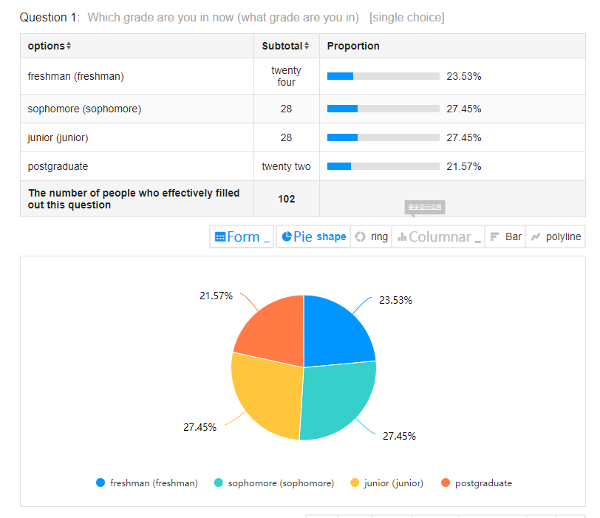

(Figure7 -- Fill in the person's grade)

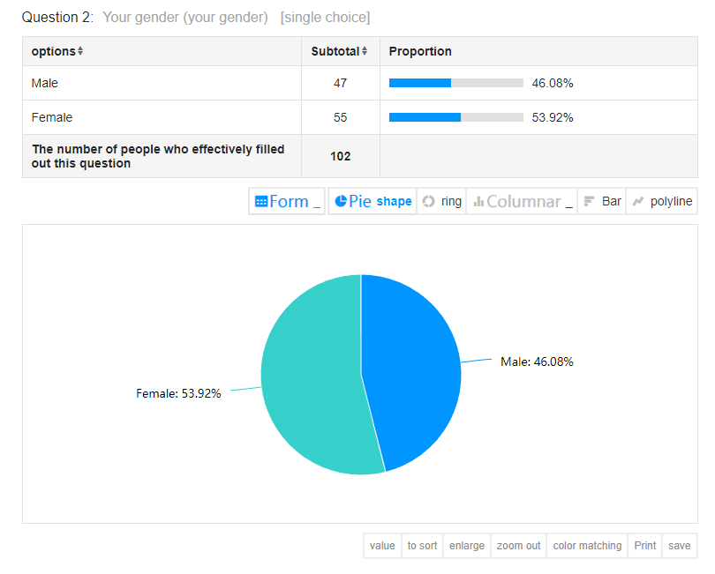

(Figure8 -- Fill in the person's gender)

The results showed that the grade and gender of respondents were roughly average, which was within the acceptable range. In addition, the survey of the grade and age of the applicants is more conducive to the follow-up study of the special characteristics and needs of people of different grades and genders, and better interpretation of the survey results.

Not only that, but I also surveyed the Wayfinder users about their ratings and how they used them. Here's what I found.

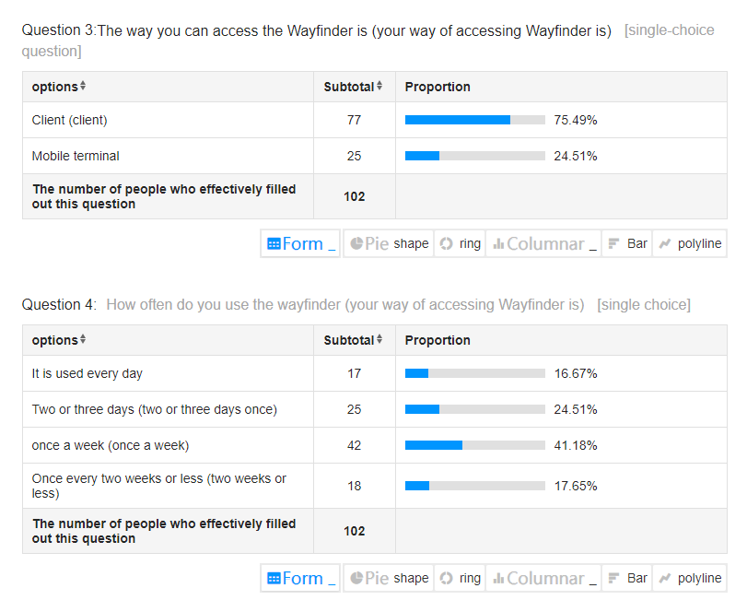

(Figure9 -- How often and how the site is used)

The results show that more than 80% of them use Wayfinder regularly -- a testament to the importance of Wayfinder for Chinese students studying abroad. And more than three-quarters of people use the client to visit Wayfinder's website - establishing that the client's web page should be the main improvement in the future.

**1.3.2 Feedback on Wayfinder's features**

After establishing the importance and necessity of improving the Wayfinder experience for international students in China, we collected Wayfinder usage ratings from respondents. In 102 valid questionnaires, the mean obtained was 6.22 (0 being the worst and 10 being the best). However, we calculated the NPS value to explore whether to praise/complain more, and the result was -40.2%.

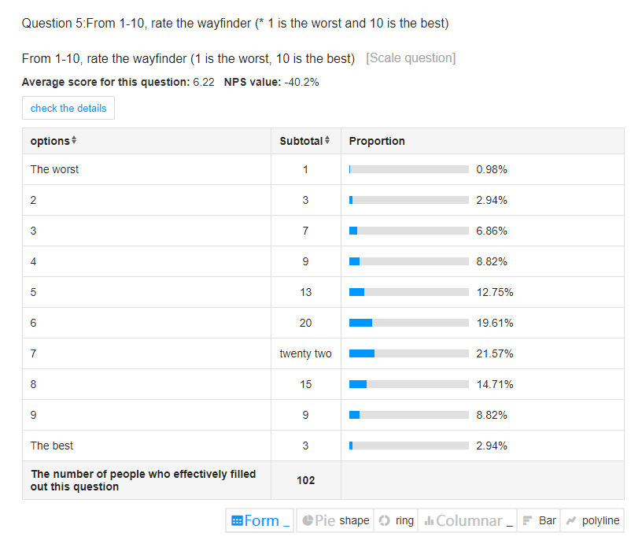

(Figure10 -- Wayfinder average score and NPS value)

NPS value is used to measure a product's customer satisfaction and loyalty. NPS values range from -100 to 100 -- positive scores indicate that the reviewer is greater than the critic, and negative scores vice versa (*What is net promoter score (NPS)? how to calculate & interpret.* 2023). In the current survey, NPS is negative. This also confirms that most Chinese international students need a better experience when using Wayfinder, and from the side reflects that it is particularly important to improve the experience of using Wayfinder.

In order to explore what functions are more important/worth improving for users, we explore the following three questions.

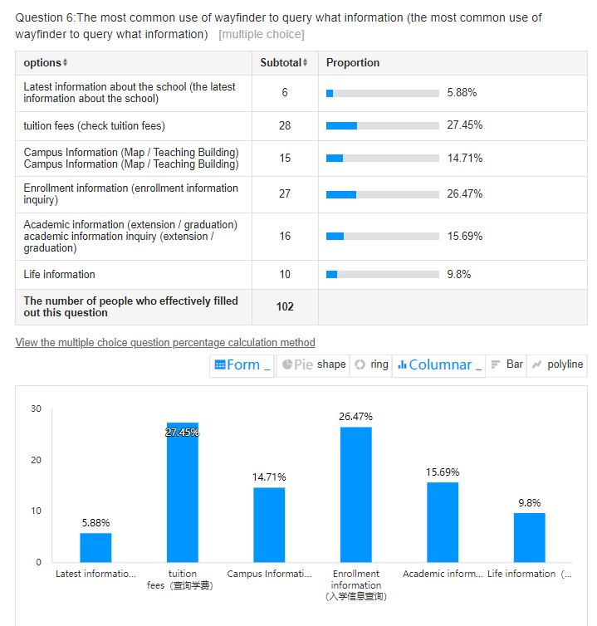

(Figure11 -- The most commonly used function)

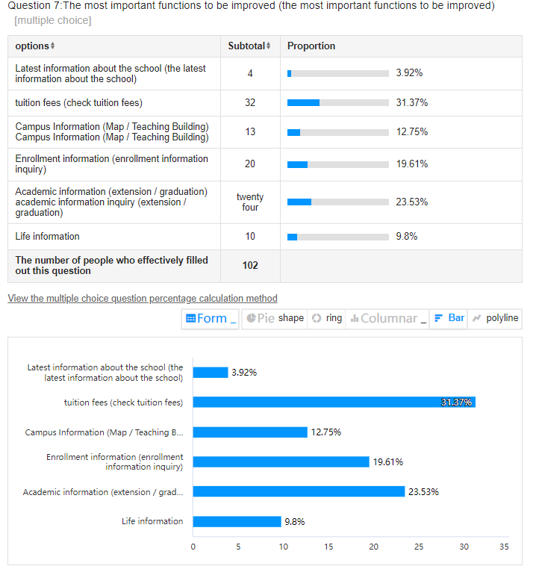

(Figure12 -- The most important feature to improve)

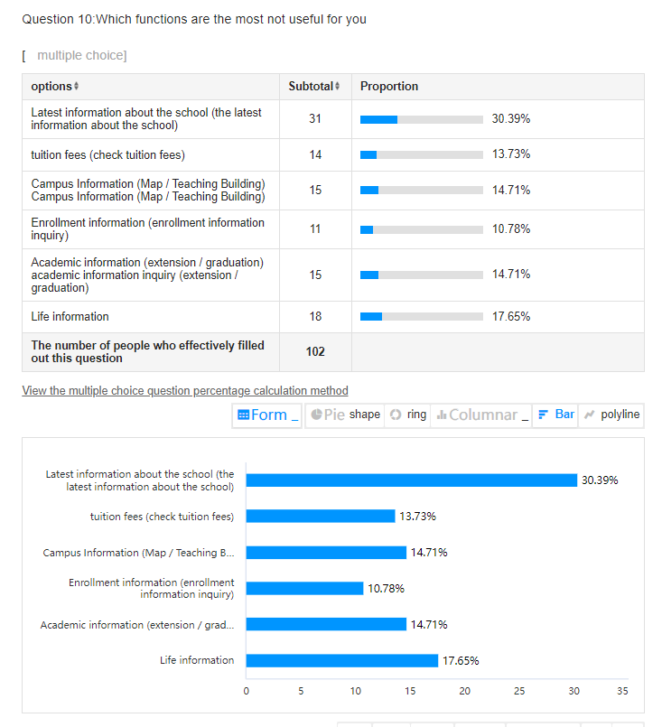

(Figure13 -- The most useless feature)

By comparison, we found that the most commonly used and desirable features had an almost equal percentage of data. Tuition inquiry is the most critical function for students, while life information inquiry is the least concerned major. In the 'most useless function for students', the latest information of the school was the most useless function for Chinese international students, accounting for more than 30%.

Through these comparisons, we find that the most desirable function for Chinese international students is to query the user experience of tuition fees. There is also a specific demand for campus maps/academic information. The information related to the school has no significant effect on Chinese students, reflecting that Chinese international students are more concerned about obtaining information about the school more conveniently/accurately when using Wayfinder.

**1.3.3 UI design feedback from Wayfinder**

Regarding the UI of the website, it is clear from the data that in each option, the proportion of people who disapprove is more than half of the total. This data page reflects that Chinese students are dissatisfied with the UI design of the website, which affects the Wayfinder website experience. Therefore, page UI design should be streamlined in the subsequent improvement, in line with students' usage habits.

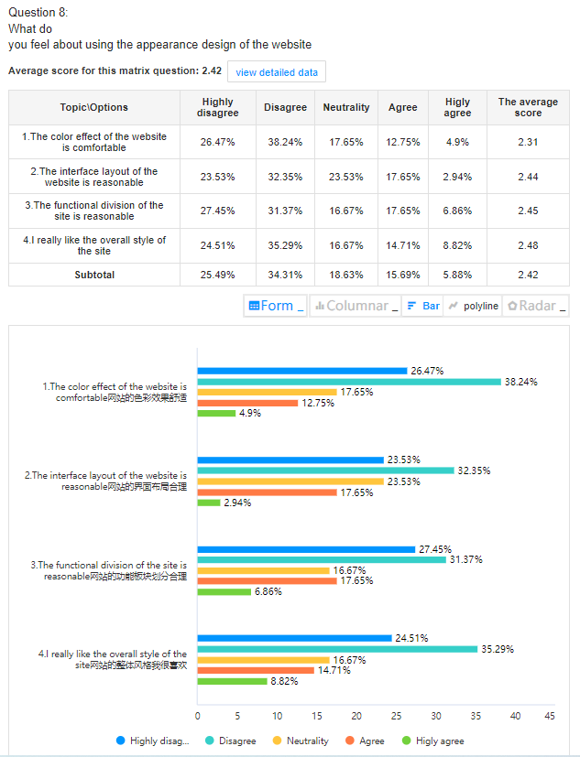

(Figure14 -- Feedback on UI design)

**1.3.4 Feedback on Wayfinder's experience**

In part about the experience of using Wayfinder, we studied from three aspects: function/query experience/information. From the data, among all the Chinese students surveyed, quite several students maintain a neutral attitude towards it. But more than half of those surveyed said Wayfinder needed to provide the information it needed. But after the actual use of Wayfinder at Coventry University, it was found that the vast majority of information is hidden in various components, which is not easy to find. Therefore, in the later improvement section, more necessary information should be placed in a prominent place so that users can efficiently accomplish their goals.

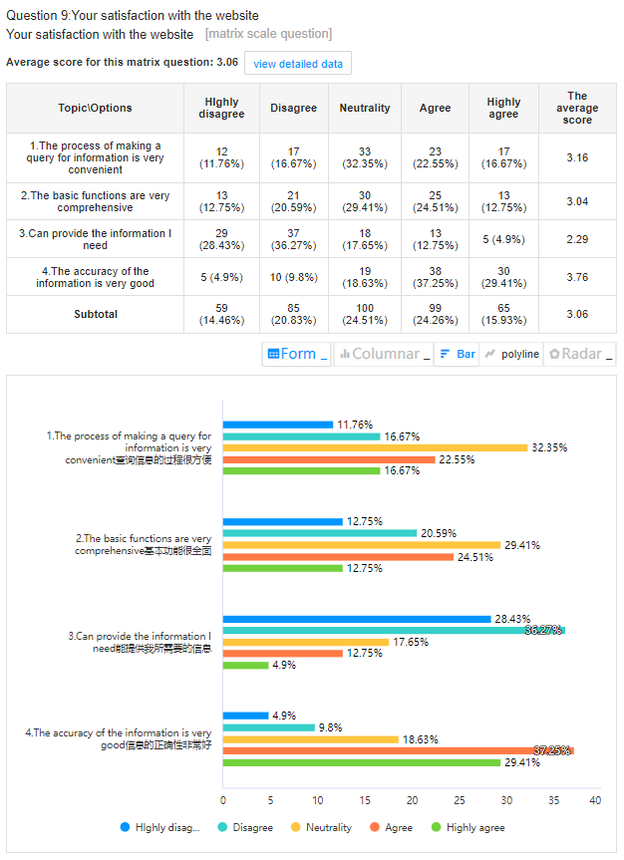

(Figure15 -- User satisfaction with the functionality of the web page)

### 1.4 Face-to-face interview: Chinese students share their views on Wayfinder website

Based on the further analysis of the questionnaire, I conducted face-to-face interviews with six Chinese international students who left their names in the questionnaire. The content of the interview is based on the questionnaire options filled in by individuals for further in-depth discussion. In the interview, I designed five questions around the questionnaire.

1. Explain Wayfinder's score further

2. Do you have any more comments or suggestions for improvements to Wayfinder's features?

3. Explain the design and satisfaction ratings and suggest ways you can improve them

4. Explain your choice and your suggestions in the emergency function selection.

5. Do you have any more comments and suggestions for Wayfinder?

In conversations with six people, I learned a lot about Wayfinder's existing problems. And made the following table.

|  |  |
| --- | --- |
| Question | Reason |
| 1. Unclear academic information in Wayfinder | The student used Wayfinder to search for extension information when he was ill, but the search process was too complicated to be successful.(P1/5) |
| 2. Homepage UI design is complex | The student tried to search for the target object, but the homepage UI design was too complex and unclear, and the problem solving page could not be located quickly(P1/2) |
| 3. Keywords are not clear | Students tried to search for information in the search bar, but because the keywords were not accurate, the experience was poor(P2/P4) |
| 4. The appearance design is not clear | Students expressed their opinions on the modular information of Wayfinder, indicating that the block information was poorly provided, which increased the difficulty of searching(P3/4) |
| 5. The practicability of campus information is low | The Coventry campus is smaller, so it doesn't need much map information(p2/3) |
| 6. The tuition inquiry process is difficult | Students' feedback inquiry tuition fee process is complicated, and the module classification is not clear, it is difficult to locate their tuition information(P1/2/4) |
| 7. The latest school news is not easy to use | Students reflect that the school's information is not applicable, with academic and life information not greatly supported(P2/4 |
| 8. Life information is less practical | Students say Chinese students have their own social platforms and organizations that they use to get information(P5) |
| 9. Add common use information for students | (P5) |
| 10. An option that requires information from other sites | The student had just arrived at Coventry University and was not familiar with all the websites. He had searched the Wayfinder web age, but nothing came of it(P5) |

Based on the summary of these information, UI design can be redesigned in the following prototype design, and the most commonly used tuition inquiry function can be changed.

## 2. Prototyping development

Based on the data analyzed through the experience questionnaire and face-to-face interviews, I began to prototype Wayfinder. In the main improvement focus of the improvement direction has the following parts:

1. Redesign the UI and modularize the functions of Wayfinder's homepage
2. Redesign the tuition inquiry process
3. Redesign the UI/ function of the tuition inquiry page

During the prototype Design, UX design software of "Just-in-time design" will be used, and a third-party element repository, "Ant Design," will be used as part of the design elements.

In addition, based on the learning in the literature review section, Wayifnder will be designed in accordance with the three design principles of UX design - usability/availability/visibility, and adhere to the 'user-centered design principle', starting from the user's perspective, to provide users with a better use experience.

### 2.1 Wayinfer home page design

According to the analysis of user feedback from Chinese students, many students have poor feedback on Wayfinder's homepage design, which mainly centers on the complexity of the homepage design page/unclear functions/unreasonable layout of components. So to address these issues, I'm going to redesign the Wayifinder page.

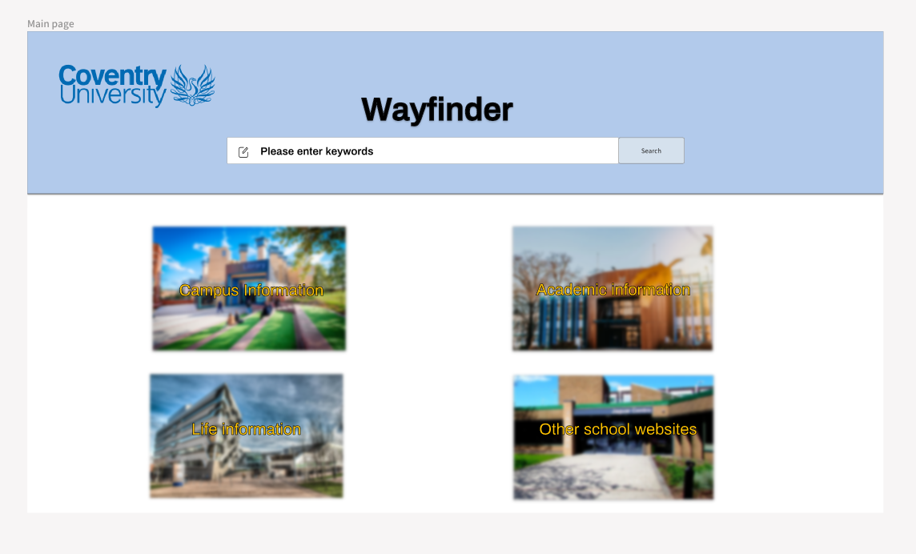

(Figure16 – Wayfinder Home Page Design)

* **Design concept**

I redesigned Wayfinder's homepage UI based on three principles of UX design. From a usability point of view, this page has been designed with the user's vision in mind - efficient/intuitive. Therefore, when designing the page, I did not design too much text description but divided the page into sections so that the user could locate the solution he needed. I put the search box in the middle for visibility and the main functionality in the centre of the page. Compared to existing websites - much more obvious to the user. Considering the availability, the division of functions and the location design of the search bar strongly provide users with the possibility of solving problems.

* **Color Selection**

In the choice of colors, I used light blue and white as the theme of the home page. First of all, blue is the official color of Coventry University, which highlights that Wayfinder is affiliated with Coventry University. Secondly, the combination of light blue and white will give users a fresh and gentle feeling and improve users' sensory experience (*Blue and white color matching, very simple and easy to use.* 2021). Not only that, but using a light blue background near the search box and a white background for the feature block can highlight the importance of the search box. And with the logo of Coventry University, reflect the Coventry University brand

* **Font selection**

I chose Archivo font as my font. This is a font suitable for online websites, which can provide efficient typography and good user experience. I also took into account the advantages of common fonts to avoid the discomfort caused by special fonts.

* **Function Selection**

To improve the functional integration part of the existing website, I made statistics and classification of the functions of Coventry University, and according to the results of the questionnaire survey, the information most commonly used by middle school students was divided into four parts: campus, academic, life and other school websites. Through this classification design, I put these four sections in the most central position of the web page so that users can quickly find the information they need. In addition, I placed a search box in the top middle of the Wayfinder site location and added a "fill in" element image to the search box to clarify what the search box does. With these designs, I aim to improve the efficiency and experience of searching for information on Wayfinder.

### 2.2 Information plate page

On the information page, I created five pieces of relevant information for each template according to the information feedback in the questionnaire feedback and five pieces of information.

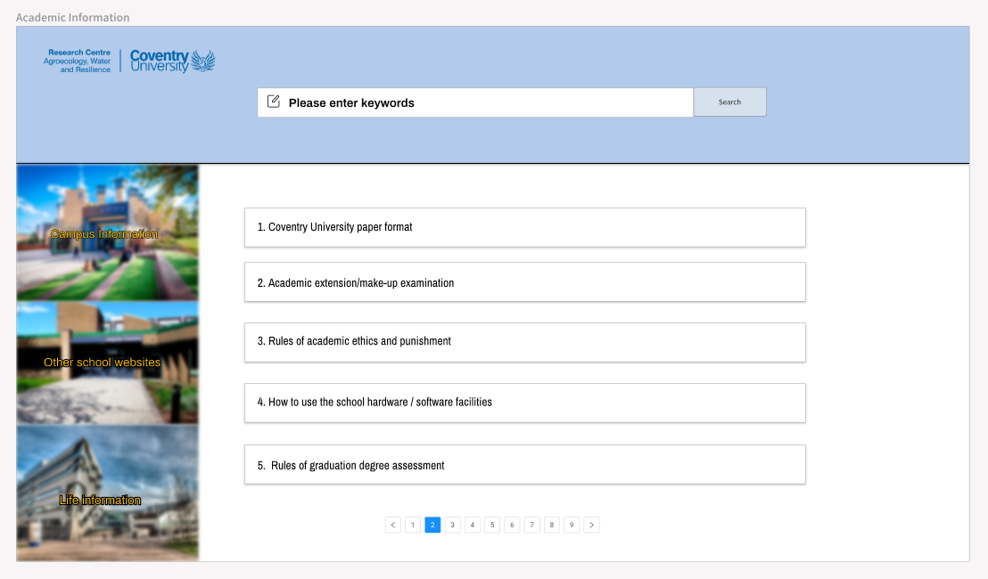

(Figure17 -- Academic information Page)

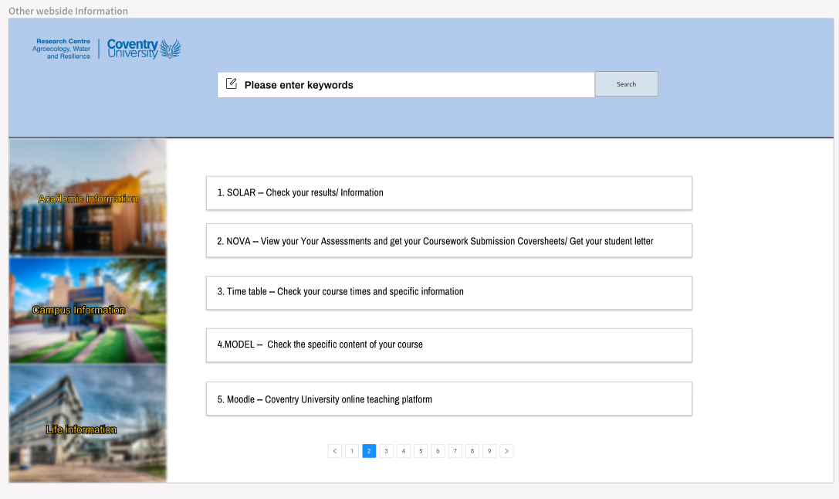

(Figure18 – Other Website Information Page)

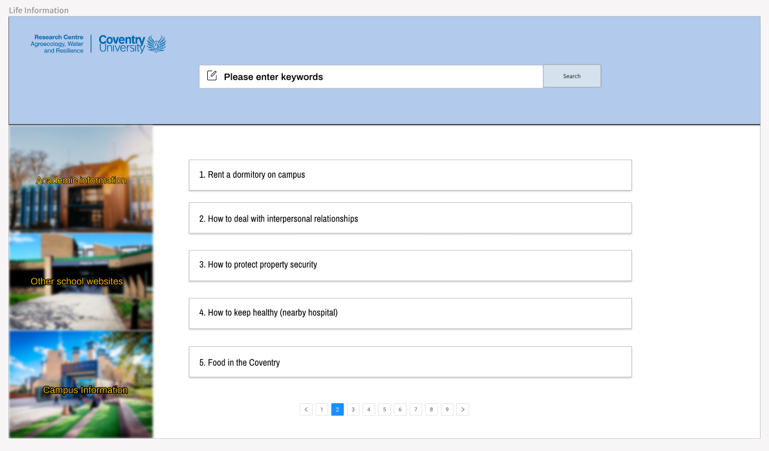

(Figure19 – Life Information Page)

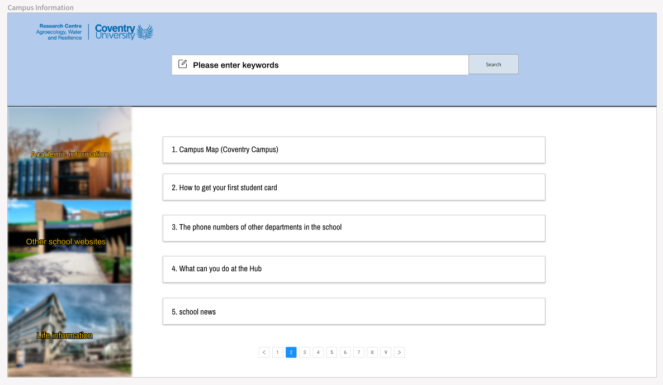

(Figure20 – Campus Information Page)

* **Design concept**

I redesigned Wayfinder's feature page UI based on three UX design principles. From a usability point of view, I use the central location, using something like a 'list', so the user can clearly locate the information he needs. It enhances the success rate of the feature that the user can implement. For visibility, I arranged each section of the widget - search box/toggle, etc. - clearly. Compared to existing websites - more efficient to provide users with actionable options. In addition to providing the information provided by the current page, the button to jump to other functions is added for the sake of availability. Centralizing all functionality on a single page - although this page mainly provides information options for this functionality - powerfully gives users the possibility and convenience to solve problems.

* **Function & Web Template Selection**

In terms of functions, I set up the information jump page of three sections except the current section on the right side of the webpage, so that students can quickly jump to other information sections for search while viewing the information of the current section. Also, to leave room for future additions, I added page number skipping at the bottom of the page -- this is more user-friendly than swiping on a single page. In terms of page templates, I used the basic design of the main page to give the user a "smooth" experience.

* **The selection of information in the plate**

According to the questionnaire survey and face-to-face interview results, many students have different needs for information in each section. So I chose 20 messages -- five for each team -- based on surveys on Wayfinder pages and daily interactions with Chinese students. By selecting information plates, students can quickly locate the target information they want to improve the experience of information queries.

### 2.3 Tuition inquiry preparation page

To give Chinese students a better experience when using the tuition inquiry function, I redesigned the tuition inquiry process. In Coventry University's existing tuition inquiry process, the main is directly searching the course name. But this can involve other constraints on the same course -- such as length of study/student status/year of entry -- that many students need to learn more about, leading to a poor experience. Therefore, I designed the preparation page for inquiring about tuition fees, allowing students to inquire about tuition fees through condition selection.

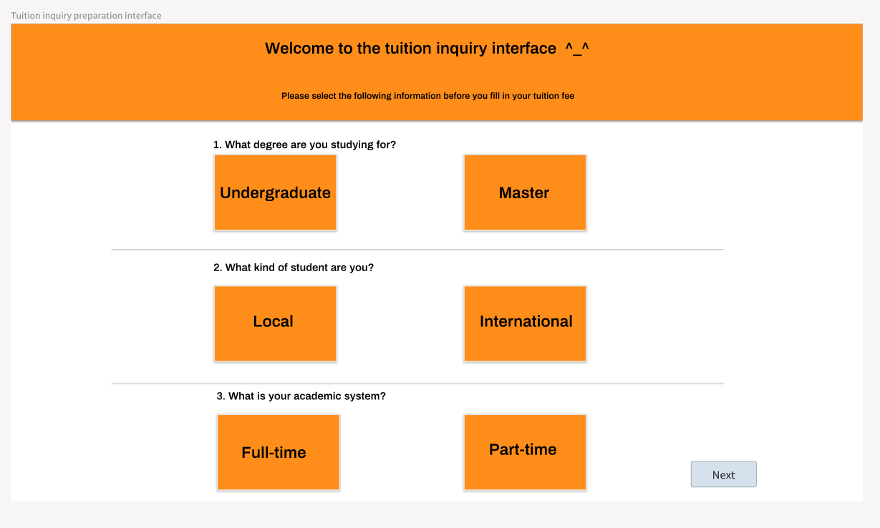

(Figure21 -- Tuition inquiry preparation page)

* **Design concept**

I redesigned Wayfinder's tuition prep page based on three UX design principles. From a usability point of view, the focus is on enabling users to locate their current conditions in a processed manner quickly. It simplifies the process of the user's query tuition. From the perspective of visibility, use large buttons and straightforward questions to let users clearly understand the system's state and how to use it. Considering the availability, through the design of the process of preparing the page, the communication between the tuition query and the user is promoted, the possibility of the user to use the tuition query is strengthened, and the user's query behaviour is supported, which effectively optimizes the user's query experience.

* **Color & Web template selection**

In terms of colour selection, I chose a combination of orange and white. Orange is a bold, bright, fresh, vibrant, and stimulating colour that can convey a positive message to users (*What is the meaning of orange?* ). The function of querying tuition fees, which requires a lot of data matching and information screening, is a big challenge and work. Using orange can convey confidence to users and ease their concerns before they inquire about tuition fees (*Designer-approved website color schemes.* ). White gives a clean, simple look. Combined, they can draw users' attention to the page, get them to pay more attention, and motivate them to take action (*How to benefit from color psychology in your website design.* ). Not only that, but the combination of the two colours can also give users a "smooth" experience and reduce their psychological burden.

* **Function selection**

In the tuition inquiry preparation page, I screened three restrictions -- degree/ Student Status/Academic system. This is because when using the existing Coventry University, these screening items will be included in one course, which leads to the misunderstanding of different screening conditions for students in the tuition inquiry process, so they need to spend more experience choosing the relevant professional course information. In addition, for the three options, I use buttons, which can make the user select the conditions quickly and clearly, and to some extent, let the user better understand the function and operation of the page and improve the user experience (KostyaStepanov, 2020).

### 2.4Tuition Inquiry Page

On the page of tuition inquiry, I found that according to the survey data and my practical experience, the existing tuition inquiry interface of Coventry University describes the process of searching tuition fees in text form.

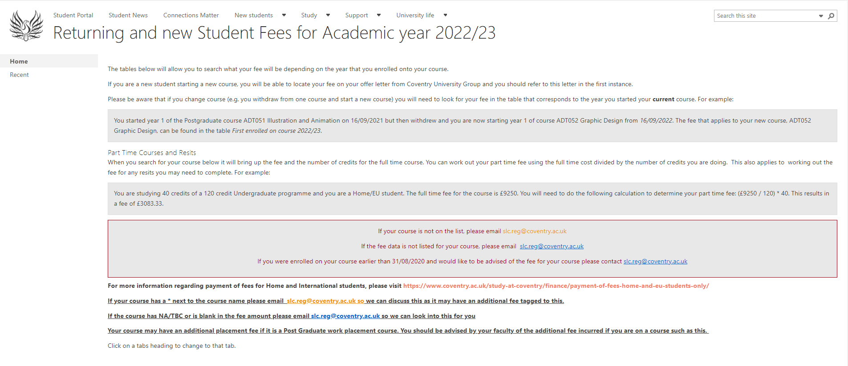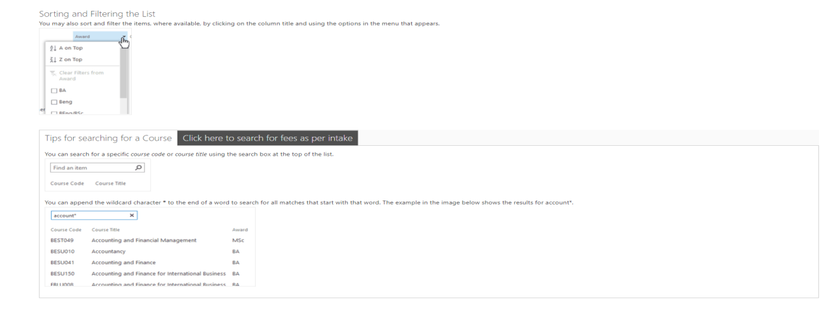  
(Figure22 -- Coventry University tuition inquiry website) (*Pages - returning and new student fees for academic year 2022/23.* )

While text introductions can provide more information and explanation, they may limit users' options and flexibility. Moreover, the official database places all the filtering criteria in the course information in the actual search interface (YXPM, 2023). Such a design violates the web design principle that not all column headings should be used as query criteria. Therefore, to improve the tuition inquiry process, I have made some improvements to the official interface.

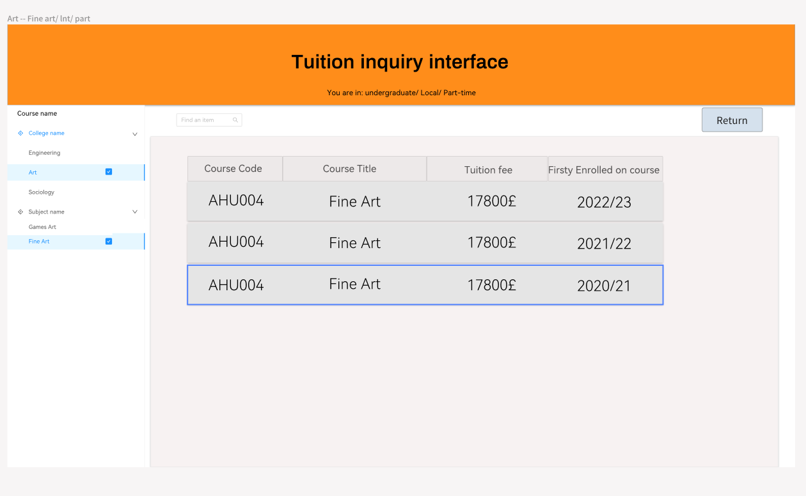

(Figure23 -- Tuition inquiry interface)

* **Design concept**

I redesigned Wayfinder's query tuition page based on three design principles of UX design. From the point of view of usability, added button/text search to choose their own professional - first compared with the existing website, need to confirm the relevant limit information, more efficient to improve the user's ease of use and practicality. And the return preparation page is designed to enhance the fault tolerance of the query tuition process. From the visibility perspective, by displaying tuition fees on a single page, users can reduce operations and query tuition-related information more intuitively. Also, when the user clicks on the following selection condition, the selection will turn blue, giving the user better feedback. Considering the availability, and the cooperation of different components/functions on the page, it provides users with powerful search capabilities. It gives users more rights to use so that they can query tuition in familiar ways.

* **Template and colour selection**

In colour design, I followed the style of the tuition preparation page, with white and orange as the primary colours. But for the database background colour, I chose a light pink colour -- to highlight the importance of the database and give the page a more three-dimensional look. In the template design, I followed the principles of web design - simple pages reasonable functional layout (Hongyang Wang, 2016; YXPM, 2023). Such a design can enable new and old users to learn quickly and improve user experience.

* **Function selection**

Regarding function selection, I have designed the option search bar on the left side of the page according to different disciplines, such as business/engineering. The design avoids the uncertainty of courses in the original database (some majors are in multiple disciplines) and allows students to search fees by discipline straightforwardly. In the database, I added a search box, which can be searched by inputting the name of the major, to facilitate students to inquire about the information of this major. In addition, I added a back button to go back to the tuition preparation page and let students re-select the screening criteria. This change optimizes the tuition inquiry process and makes it easy to use.

# Chapter Ⅴ: The Software Development Process Of Coventry University Wayfinder Website

## 1.Front-end development ideas

In the front-end development of this project, I used Vue as the front-end framework and Ant design as the UI dependency of the project. The following will introduce my ideas in front-end development through the example of building the website's main page.

**Before development:**

To get started, I used Vue scaffolding. I first set up an empty project framework and installed the node environment and Vue-CLi tools. So I created a Vue 2 version of the project, edited it and ran it in vs code.

**Main page Design:**

After completing the construction of the framework, the website's main page will be designed because it considers the whole site's style and colour matching. I chose to use the components and styles provided by Ant Design to optimize the UI.

**Development of page components:**

When completing the design of the main page, I developed the components on the main page. For example, I divided four information function areas on the home page. So I used Vue's component philosophy and took advantage of the components and styles provided by Ant Design.

**Data transfer and state management:**

After developing each component, I need to think about the management of information. In this part, I'm using Vue props and emit for passing data between components and Vuex for global state control.

**Optimize the page and check the spec:**

To check whether the page meets the design requirements, whether the function is working correctly, and whether the code has errors or redundancy, the performance and user experience are optimized. I used tools like eslint to check code specification and quality, and tools like webpack to bundle and minify code for faster loading times.

## 2. Backend development ideas

After completing the development of the front end, the back end was started. Compared to frontend development, backend development steps and ideas will be much simpler. The steps are as follows

1. Set up a Spring boot project in the IDEA compiler to quickly create Java-based Web applications. Then I added Lombok/Spring boot Dev Tools/Spring Web dependencies, allowing me to write code more efficiently during development.

2. Add Spring Data JPA and MySQL dependencies. This way, I can make it easier for me to access the database and facilitate the operation of the database in the subsequent development.

Configuring the database connection: In the application.properties file, we set up the database connection information - including MySQL URL/ username/password, etc. Let the application can interact with the database data.

4. Create a new entity class: Under \server-api\src\main\java\com\example\api\model, create a new entity folder, and create a new entity class Course, Major, Tuition. This entity class will map the database tables, making it easier to work with the database.

5. After the above steps, I will launch the application and automatically create the table via Hibernate - a necessary step to ensure my application can access the database.

**Design of Database**

In this project, we used the database to query the tuition fees. Because in the query tuition page, I designed that users can query by clicking on the search bar and search tuition fees directly in the search box, so the structure of the database I designed is as follows:

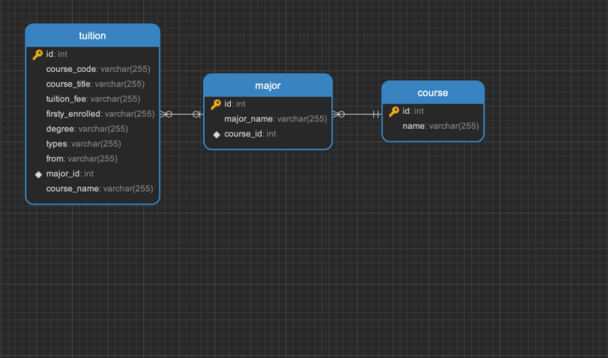

(Figure24 -- Database design diagram)

Through this design, the three databases of Course, Major and Tuition can be associated and displayed in the actual page.

## 3.Important components developed for the first time

### 3.1The search box

In the homepage design, I designed the design box so that students can search for the information they want to query. The way it works is that through the information entered by the student, the front-end uses regular expressions to match the data source and then uses CSS to highlight the information queried by the user on the data source.



**Code implementation:**

Main.vue

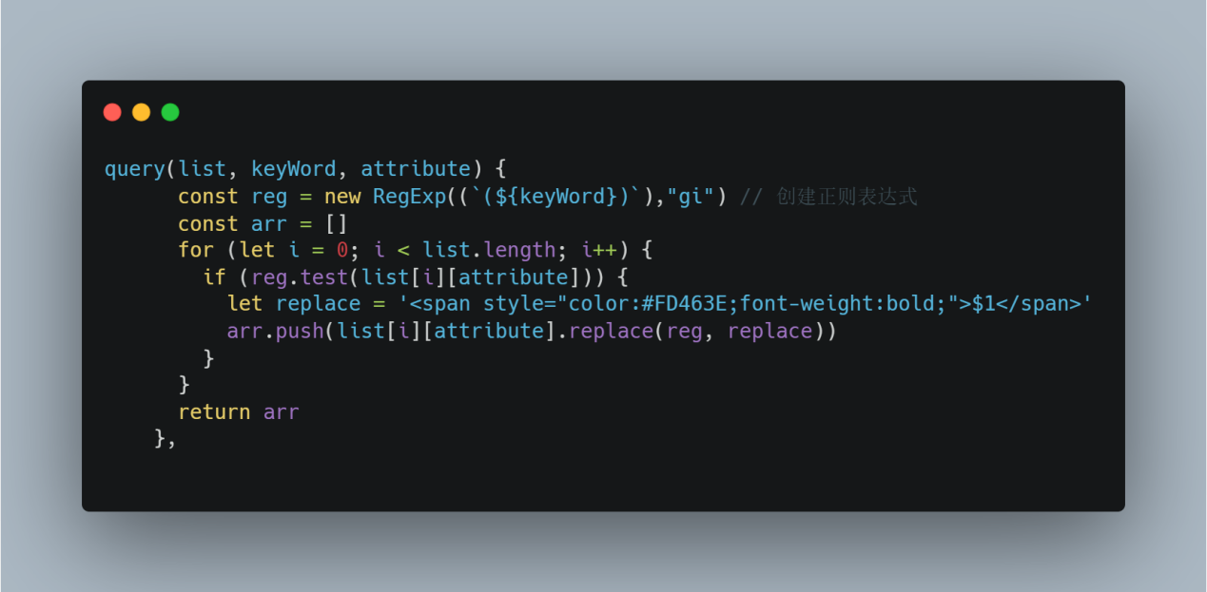

### 3.2 Paging components

After entering the module information, I designed the button to jump to the page. Because we were designed to display only five pieces of information per page, to render the data on a single page, we need to use the Go button to navigate to another page.

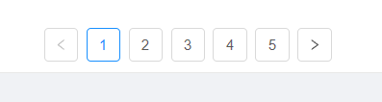

**Code implementation:**

**Front-end:**

Information.vue

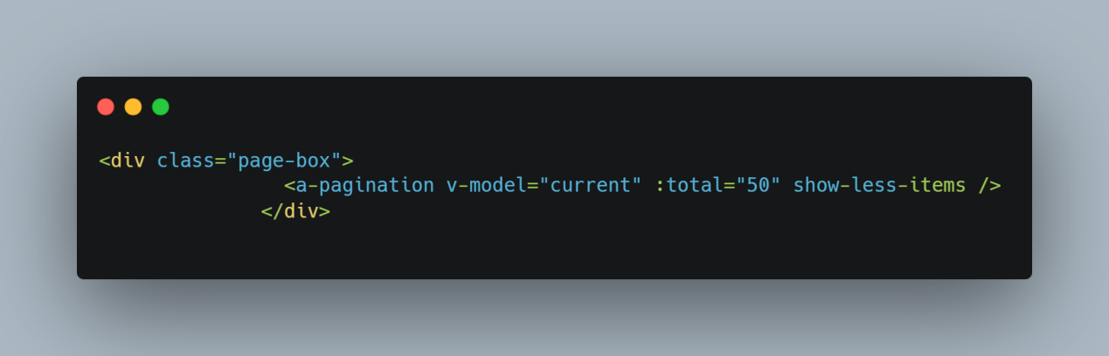

**Styles:**

Information.vue

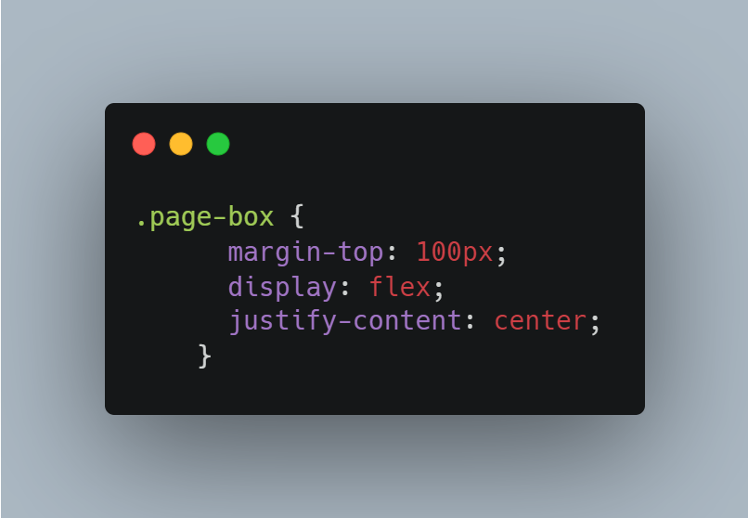

### 3.3 Prepare the tuition inquiry page -- Button function

In the page of preparing tuition query, I prepared three questions for the user -- six buttons to match the user's basic information. The implementation logic is that the user selects the corresponding option and saves it with vuex first, if the user does not select all the options, You haven't finished selecting, please continue selecting will be given the corresponding prompt. After selecting, click Next to jump to the tuition query page. At the same time, the data selected by the user is obtained from vuex and transferred to the back-end for query through the interface.

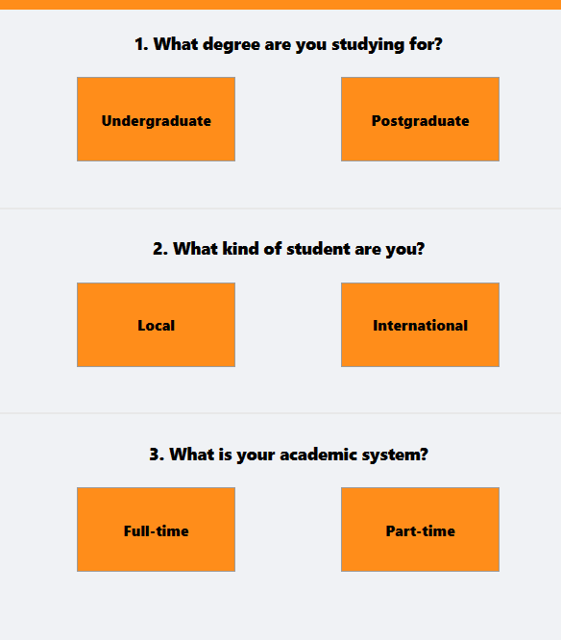

**Code implementation:**

**Button component code:**

Preparation.vue

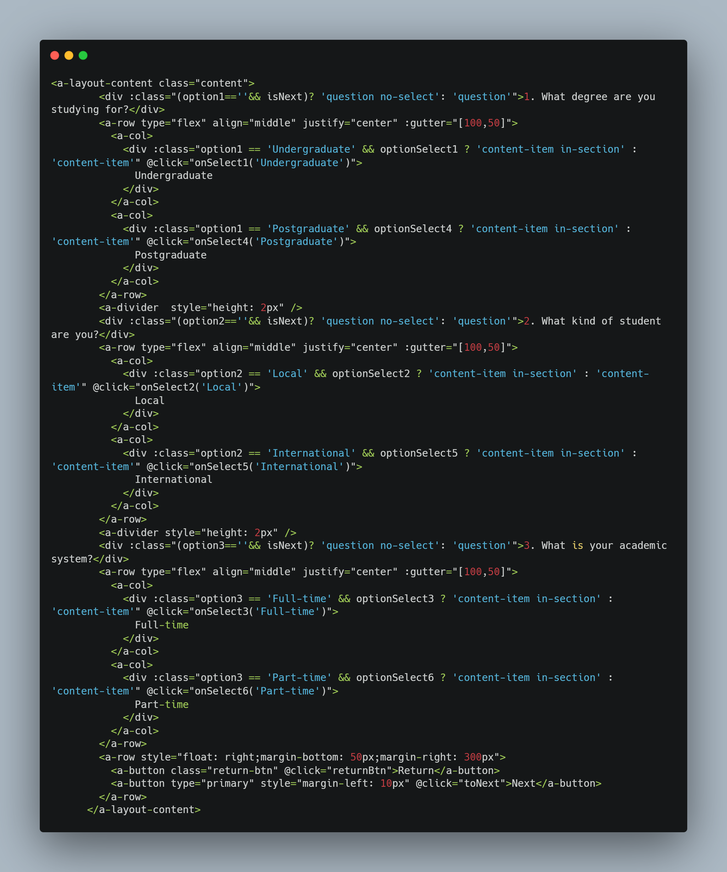

**Button logic implementation:**

Preparation.vue

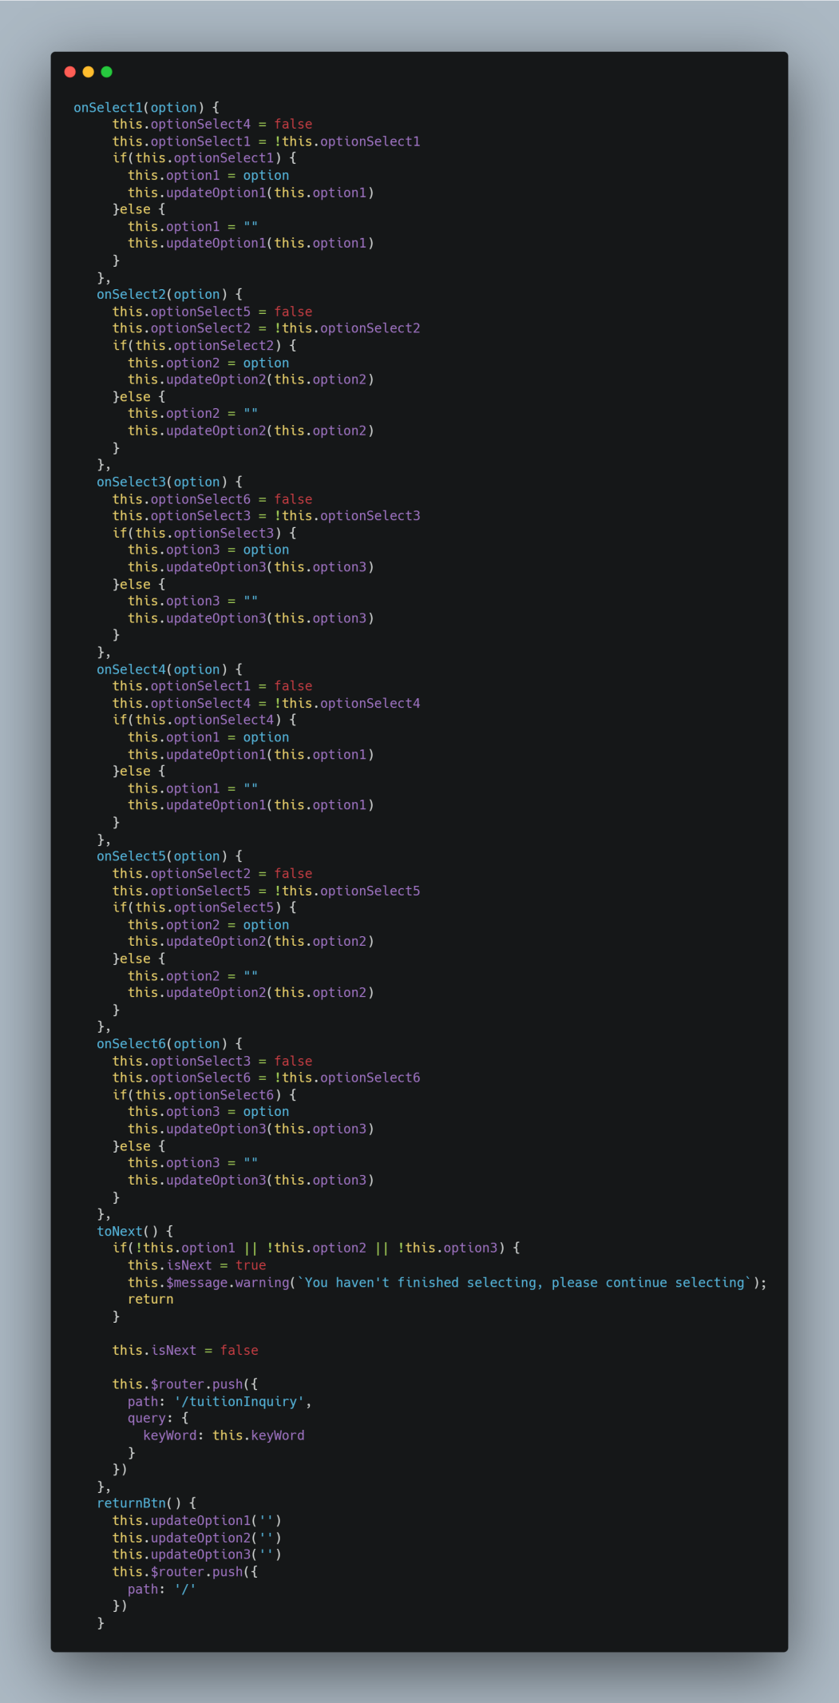

**Interface query code:**

TuitionRepository.java

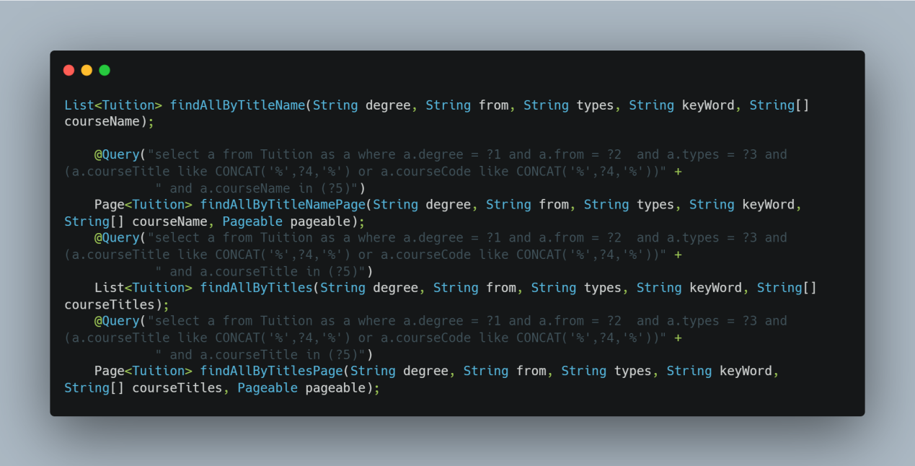

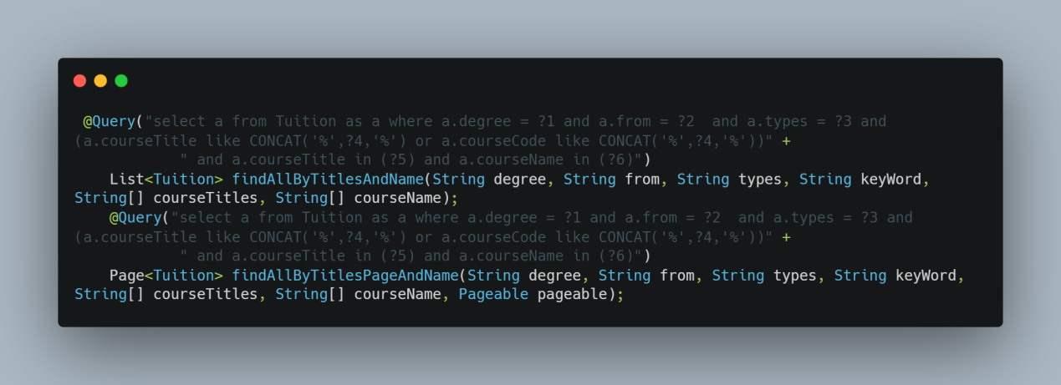

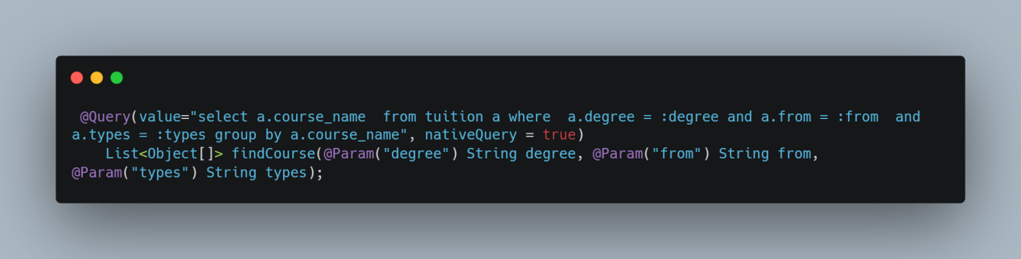

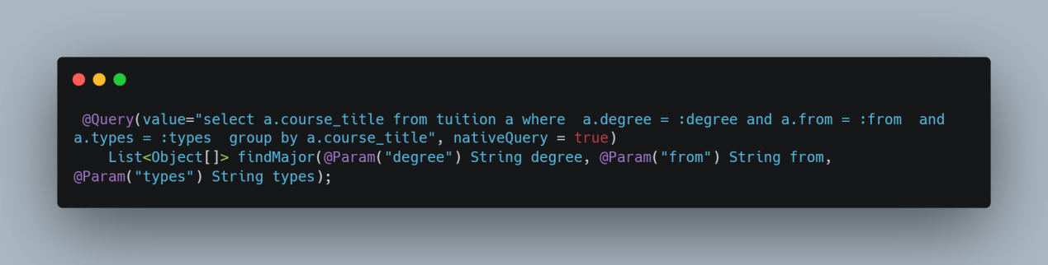

### 3.4 Query Tuition page - search box

According to the prototype, set up a search box on the right side of the query page. The principle is that the user chooses the button of a subject and chooses the detailed major, and the information of the relevant subject will be displayed in the database display bar on the right. Parameters selected by the user are retrieved in the database by sql statements.

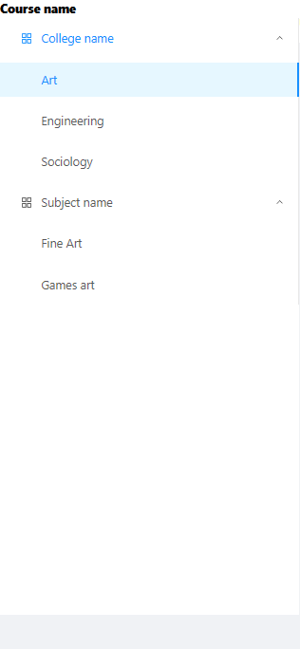

**Code implementation:**

Front-end components:

tuitionInquiry.vue

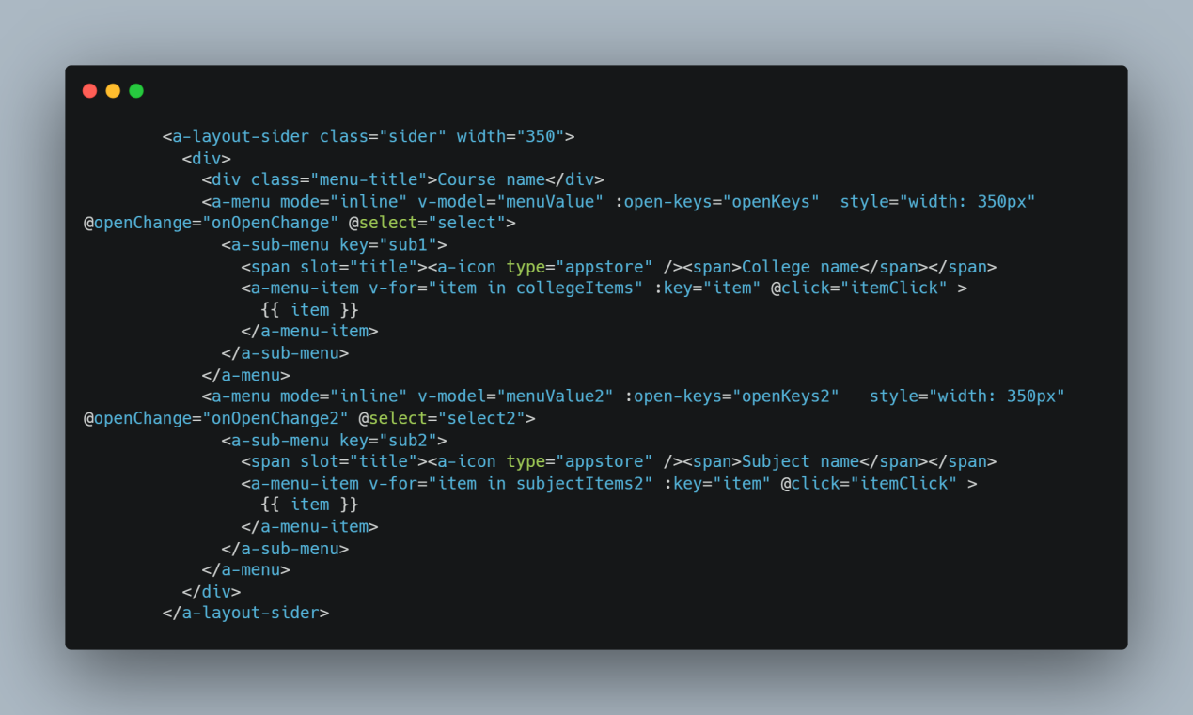

**Related logic:**

tuitionInquiry.vue

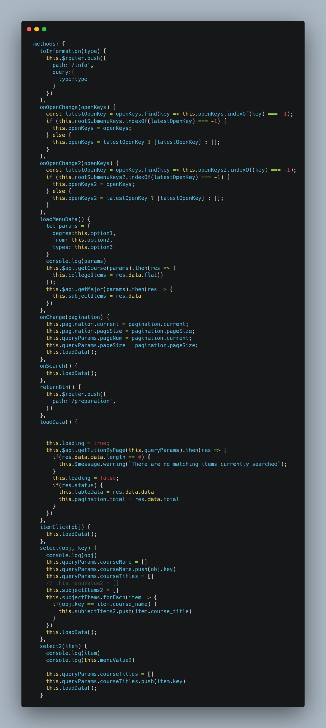

**The backend code:**

TuitionContriller.java

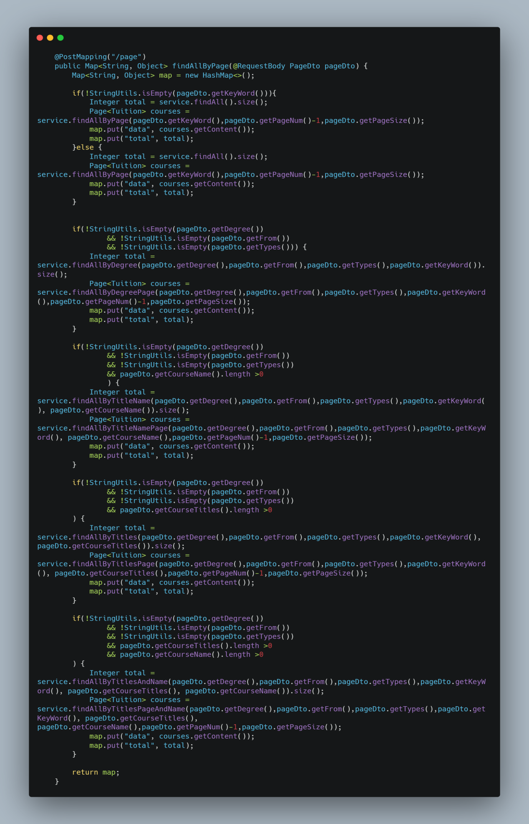

### 3.5 Query tuition page - Text search box

In the query tuition page, the specific information of the discipline is also queried by the name of the query discipline. The user inputs the keywords to get the keywords entered by the user from the front-end to the back-end from the interface, and the CourseCode and CourseTitle are carried out through the sql statement.

The fuzzy query matching is carried out in the database, and the data is returned to the front end in the form of json for data rendering.

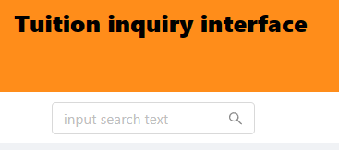

**Code implementation:**

**Related code implementation:**

tuitionInquiry.vue

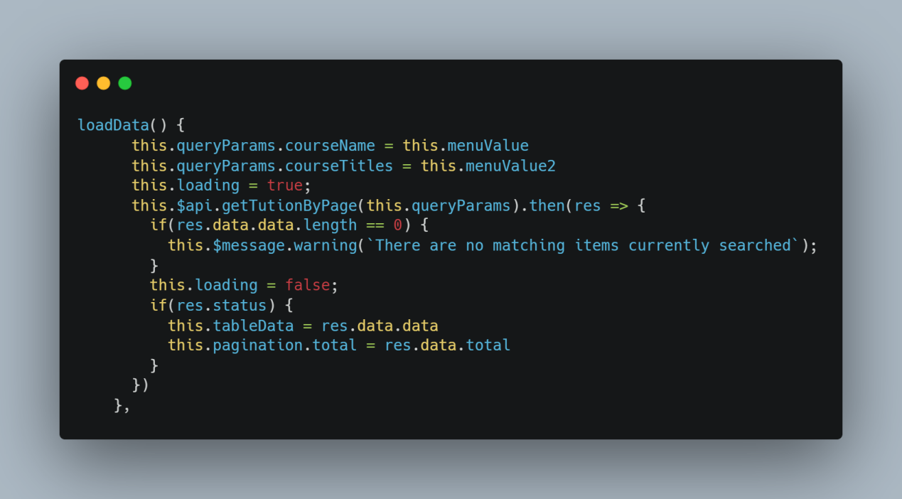

**The front-end search box design code:**

tuitionInquiry.vue

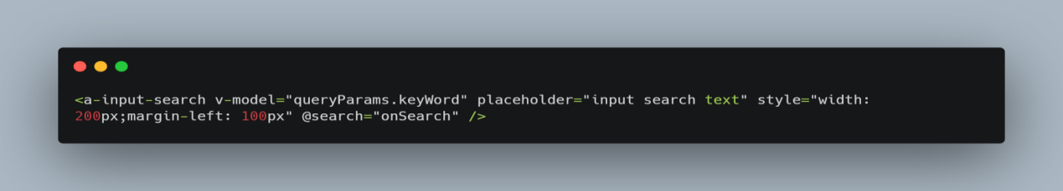

**The backend code:**

TuitionController.java

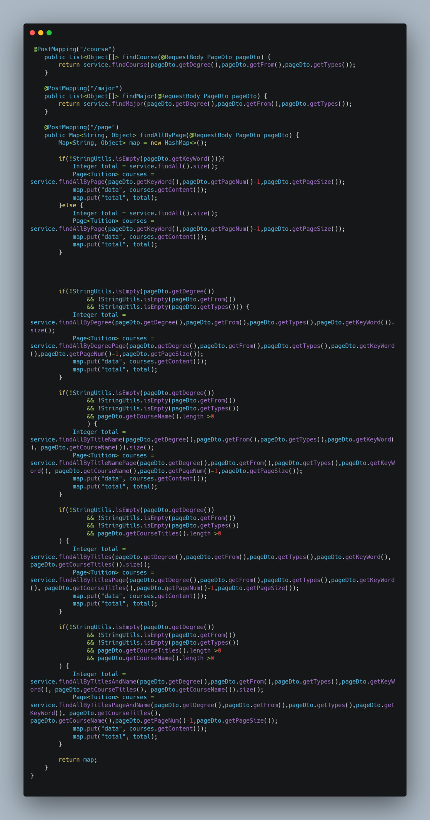

### 3.6 Query tuition page -- Database visualization

In the most central part of this page, it returns the specific information of the user query data. The working principle is that the front end passes the parameters selected or input by the user through the post interface, and the back end receives the parameters passed by the front end through the corresponding interface and uses sql statements to match the corresponding data. The front-end gets the data through the interface callback and performs data parsing and data rendering to the page to realize database visualization.

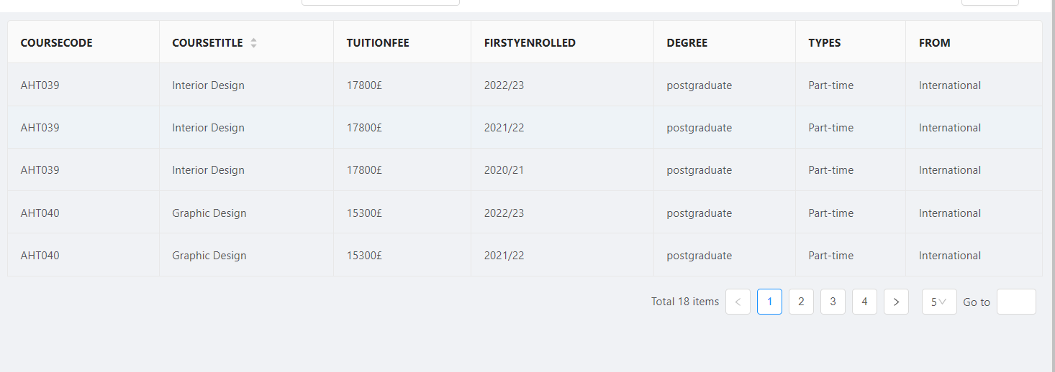

**Code implementation:**

**Front-end table component:**

tuitionInquiry.vue

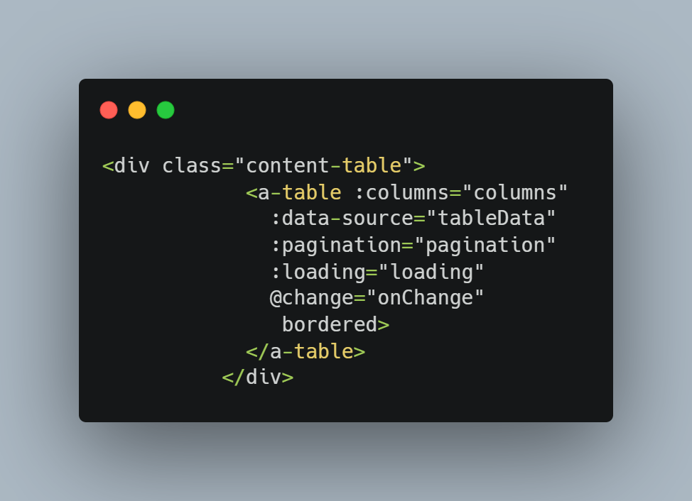

**Data query code:**

tuitionInquiry.vue

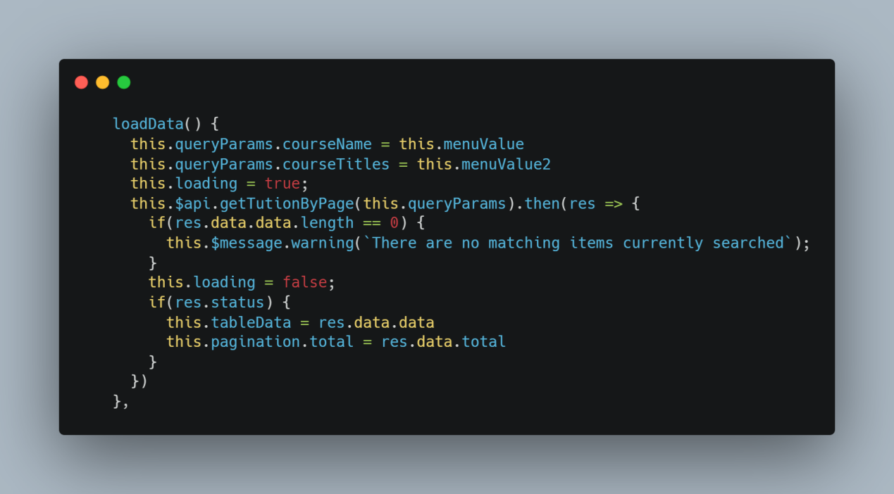

**Backend interface query:**

TutionController.java

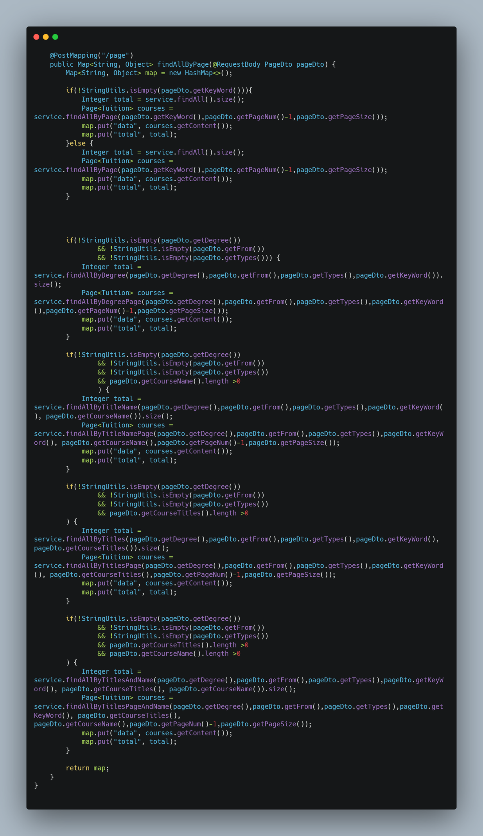

TuitonRepository.java

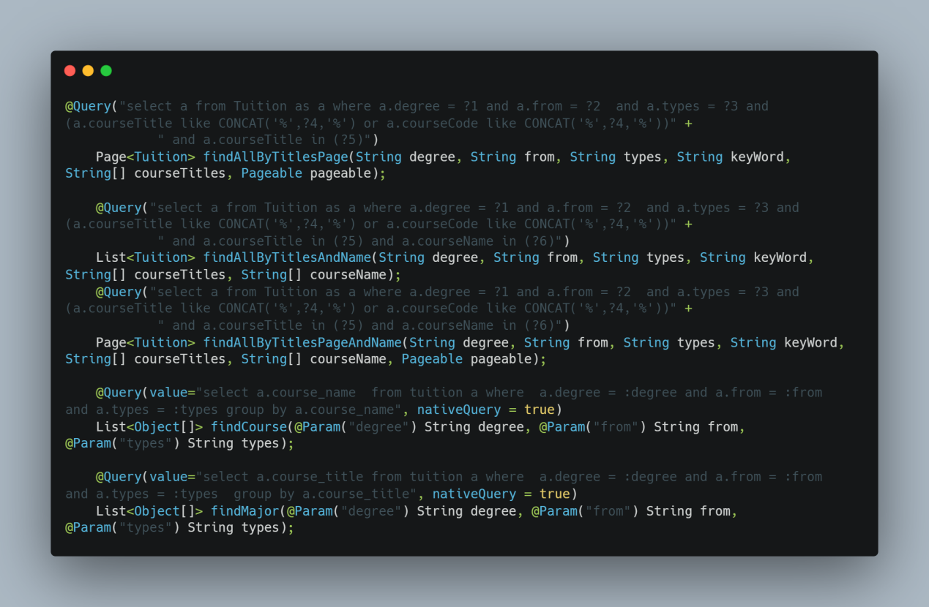

## 4. Important components of the second development

After the completion of the first version of the software, I conducted a survey through face-to-face interviews with users and got a lot of feedback. After sorting out the feedback, I decided to make changes to the page UI and functionality in the following sections.

Home Page

1. The search bar adds a fuzzy search for the query information

2. The Record bar - keeps track of what the user has searched for

3. Common Contact column - lists department information that may be used frequently

Plate interface

1. The ICONS on the left side of the page differentiate from the information section in the middle

2. Added help request text

Tuition inquiry preparation column

1. Add a button to return to the home (search) page

2. Add popup prompts and title changes if not all selections are available

3. Add the reselect button to cancel

Tuition Fee Enquiries:

1. Increased the amount of single-page data you can customize

2. Added the ability a-z to sort the course names

3. Added the ability to query tuition data through the discipline code

4. Added breadcrumbs path

5. Added help request text

Next, I'll describe how the important components work and what the code makes up.

### 4.1 Fuzzy search for infoboxes

In order to facilitate the search for information, I added the fuzzy search option to the title of the content in each template. Users can search by a single word or a single word in a sentence, and automatically match the title of the existing information. The principle is to use regular expressions to fuzzy match keywords and css to highlight keywords.

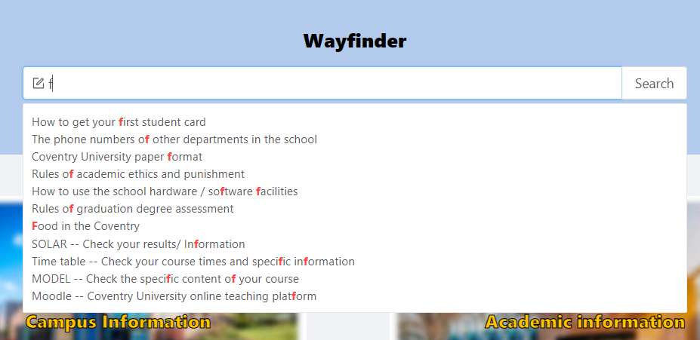

**Code implementation:**

**Front-end search box:**

Main.vue

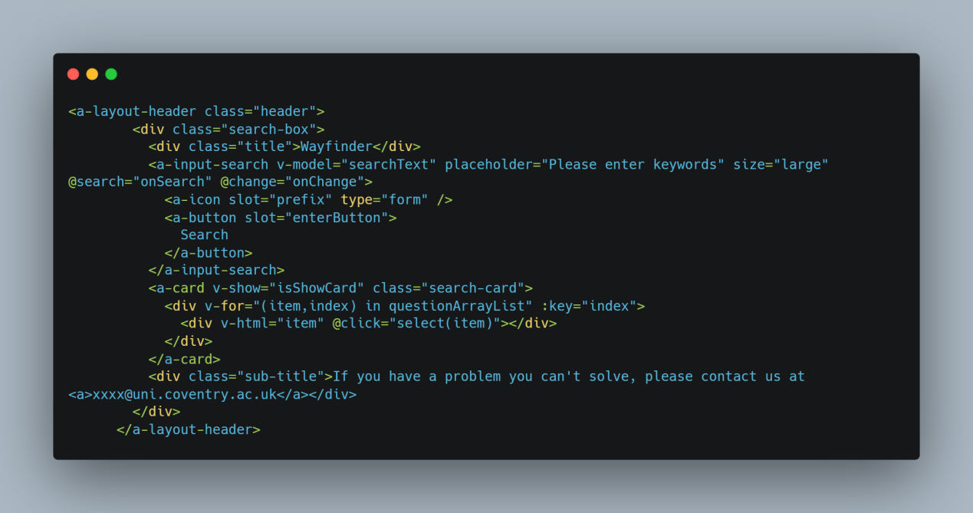

**Implement the logical method:**

Main.vue

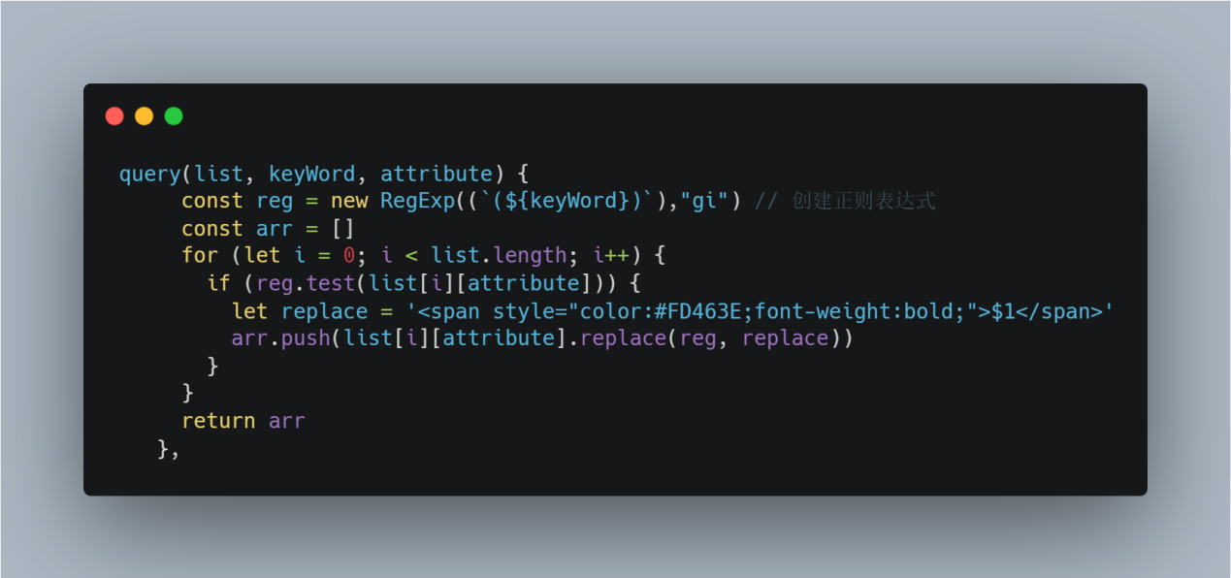

### 4.2 Search the records bar

In order to facilitate the search of user query information and facilitate the next query, the text/web page title of the user search will be recorded. The main implementation principle is to save the query record entered by the user through the localStorage of the browser. After clicking the query button, the query record is fetched from localStorage and rendered to the search record bar component via vue two-way data binding.

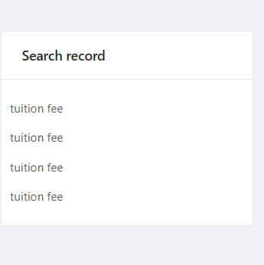

**Code implementation:**

**Search bar components:**

Main.vue

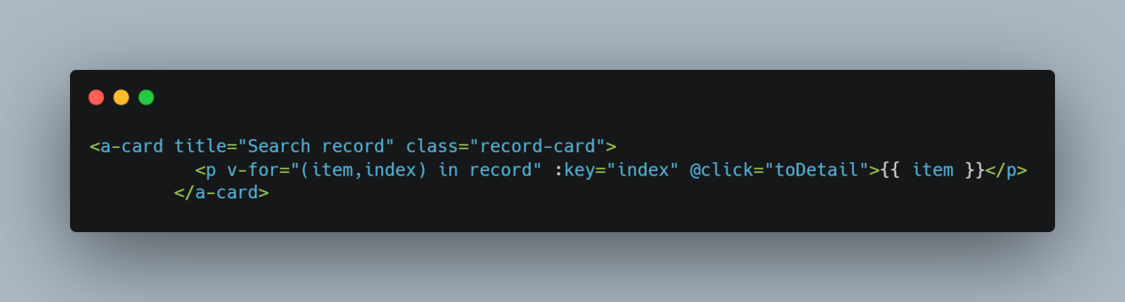

**Implementation logic:**

Main.vue

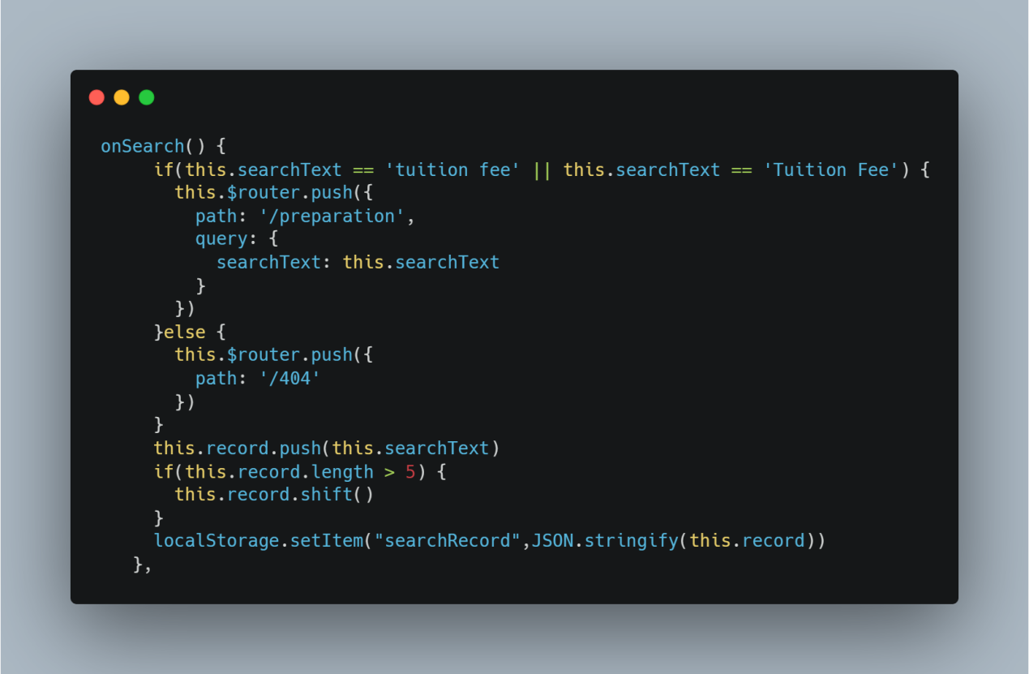

### 4.3 Error Return popup

In the tuition search page, in order to remind the user that not all options have been selected, the system will automatically popup prompts that not all options have been selected, and in the title of not selected items, it will turn red to prompt the user to select. The implementation principle is through the two-way binding of vue data, after creating the option variable, the component style is controlled and whether the pop-up window is displayed through the value and no value of the variable plus the variable that controls the style display, and the pop-up window uses the message component of ui.

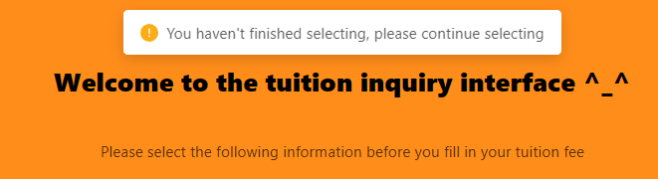

**Code implementation:**

**The popover uses ant design vue's message component:**

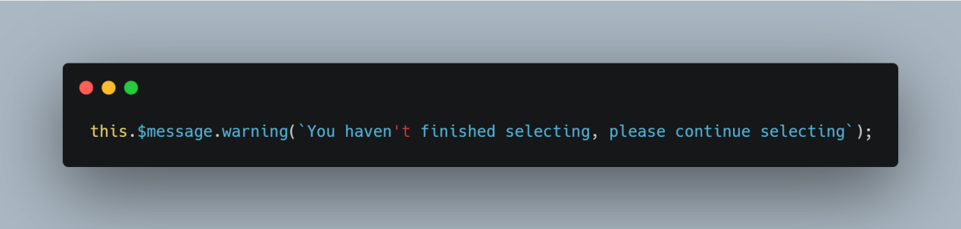

**Front-end dom elements:**

Preparation.vue



**Css styles:**

Preparation.vue

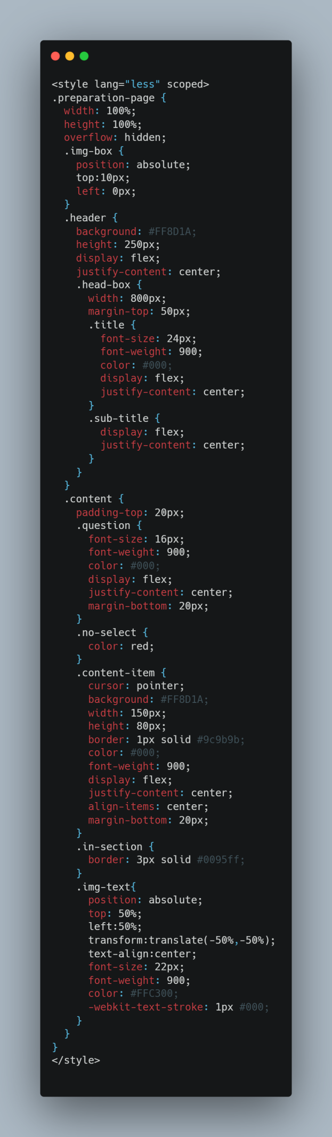

### 4.4 Breadcrumbs path

In order to facilitate the user to know the current location in the query page interface -the option selected in the tuition preparation interface, in the tuition search page, the breadcrumb path is added to facilitate the user's current positioning. How it works is that the front end saves the parameters selected by the user with vuex, jumps to the next page and retrieves them with vuex.

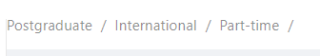

**Code implementation:**

**Component uses ant design vue breadcrumbs component:**

tuitionInquiry.vue

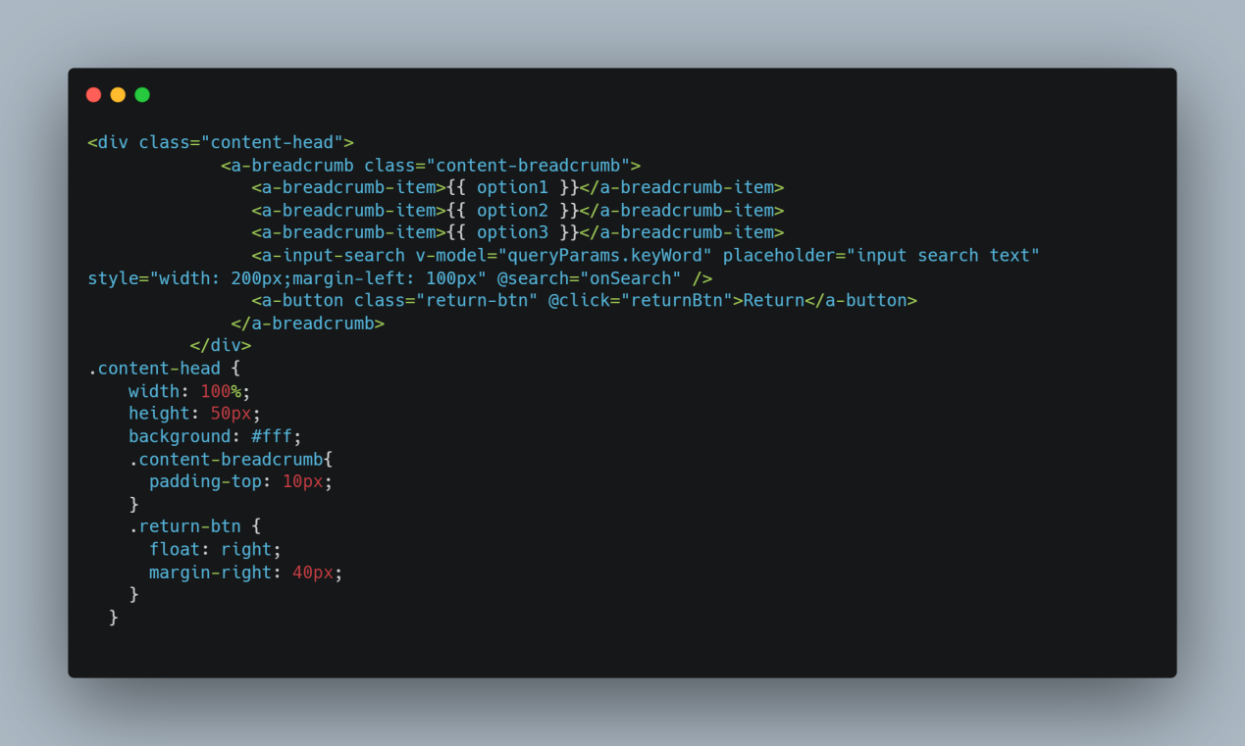

Vuex implements:

Preparation.js

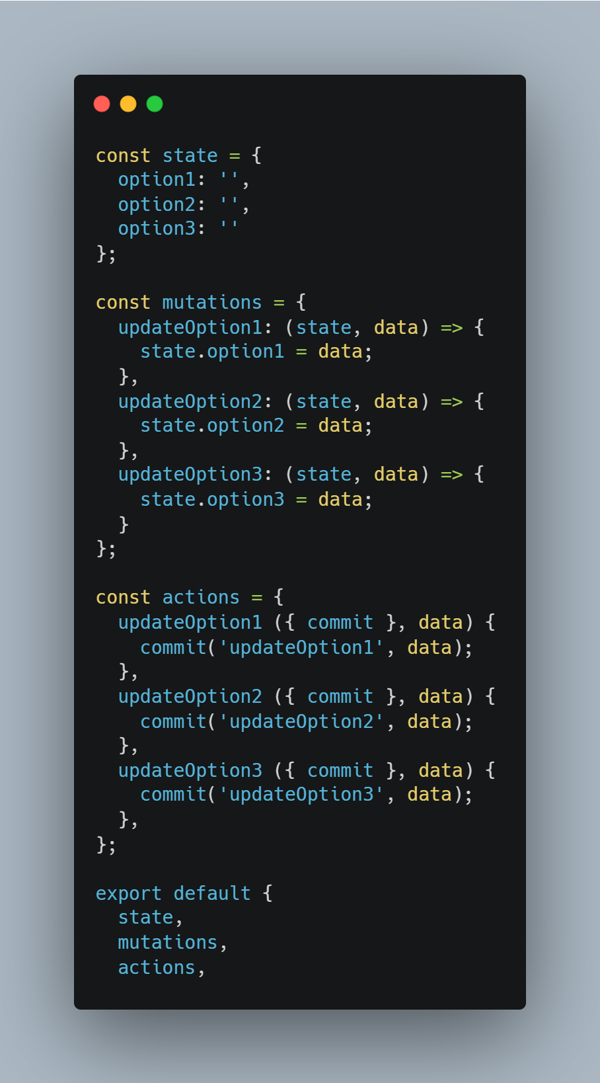

### 4.5 A-Z sort the specialty names

In order to facilitate users to query in the database, the A-z sorting of the subject name is added to the data column of each professional name, which is convenient for users to view. The sorting is realized by the custom sorting of the table component of the ant design vue ui framework.



**Code implementation:**

tuitionInquiry.vue

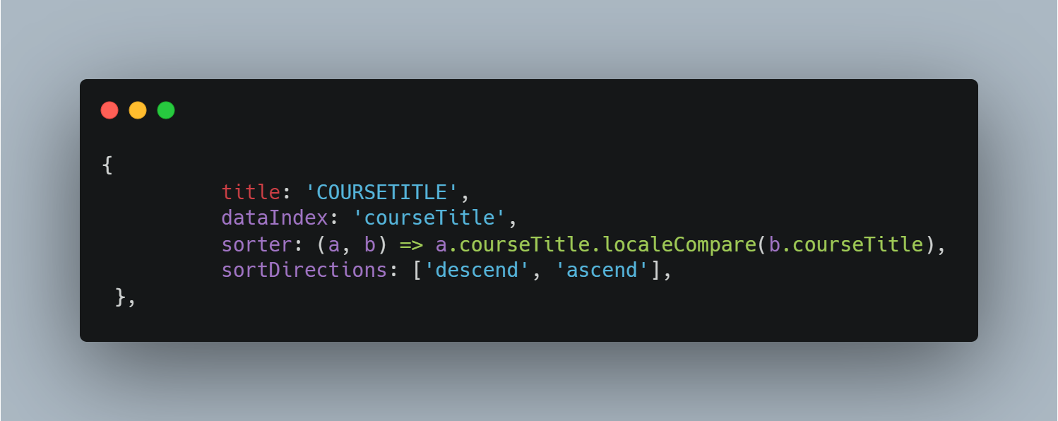

### 4.6 Search the discipline code in the search box

In order to facilitate users to query the specific information of the discipline on the premise of knowing the discipline code, the direct query of the discipline information using the discipline code is added. The principle of implementation is that the front-end obtains the fuzzy keyword of the discipline code input by the user and passes it to the back-end for sql fuzzy matching of the discipline code field, and returns to the front-end after the matching is completed, and the front-end renders.

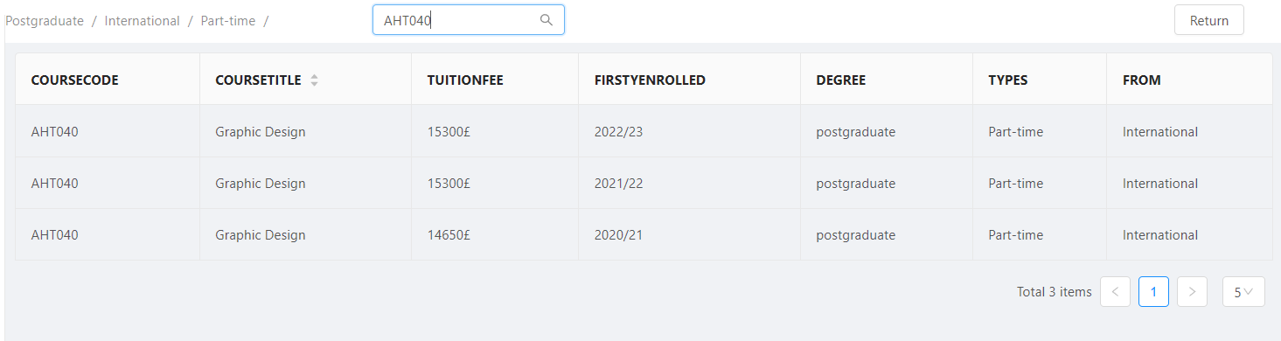

**Code implementation:**

**Backend code:**

TuitionController.java

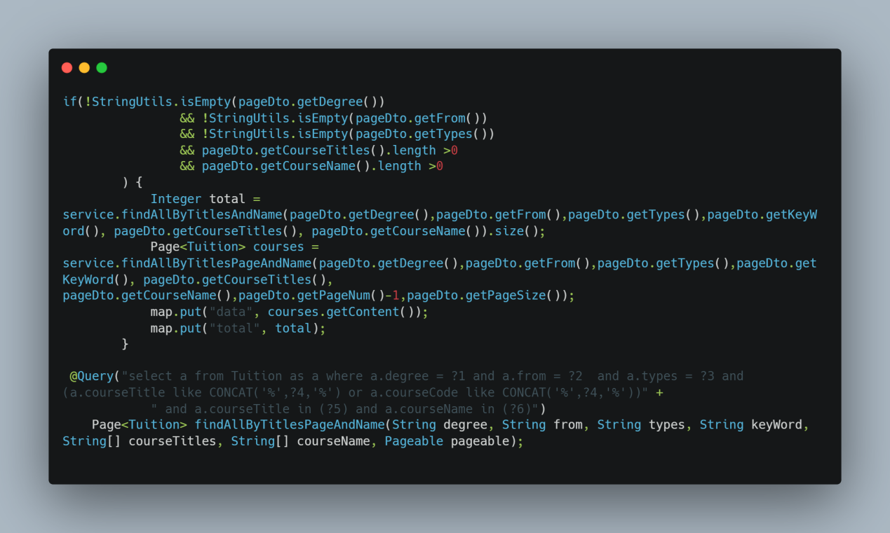

**Front-end code:**

Base.js

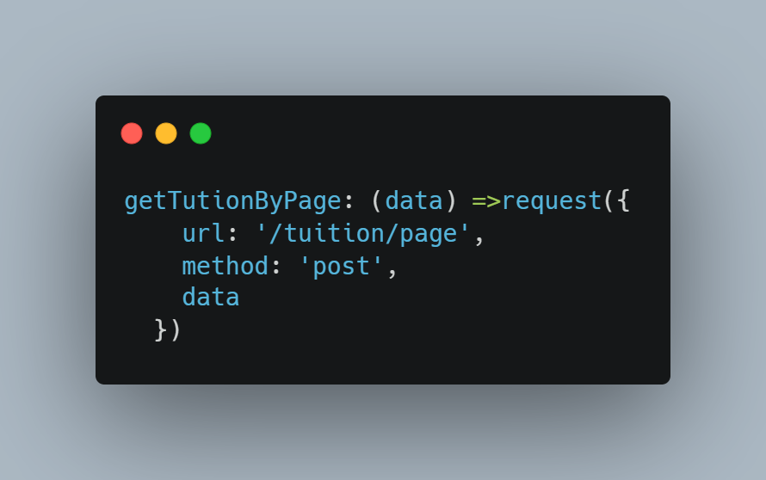

tuitionInquiry.vue

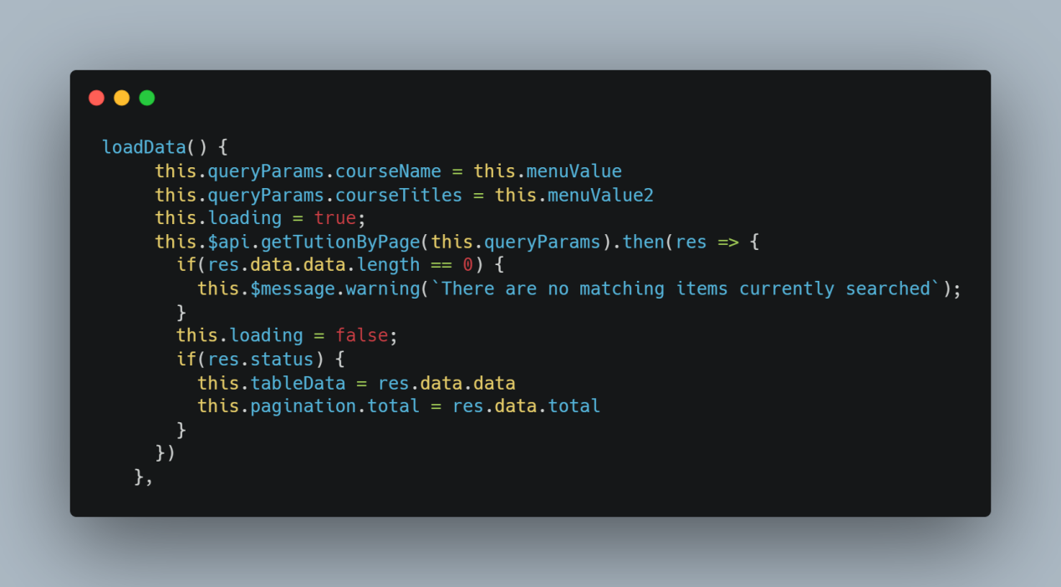

# Chapter Ⅵ: Discuss current and future value --- improving the Coventry University Wayfinder website

## Discuss the value of the current work

According to the feedback of Chinese international students, the improved Wayfinder website has tremendous changes compared with the existing Wayfinder website, which is more in line with the needs of Chinese international students and improves their sense of user experience. In addition, the change of the website can provide precious research processes and products for Coventry University to improve the Wayfinder website in the future -- for how to improve international students (not only Chinese students) because the number of international students at Coventry University is among the top in the UK. Therefore, according to the research process and the final webpage of this project, it can help Coventry University better to understand the needs of international/Chinese students and provide better sustainable services for international students.

## Discuss the future value of current work

According to current data analysis, Chinese students already account for one-third of non-EU international students in the UK (Richard Adams, 2020) . And on the predicted trajectory, the number of Chinese undergraduates in the UK will rise by 24,000 by 2030 -- a staggering 70% rise in 2021 enrolls (*Boomtime forecast for chinese applicants to UK HE by 2030.* 2022). Moreover, the proportion of Chinese mainland undergraduates applying for graduate students in mainland China is decreasing yearly. (San Chen, 2022) The United Kingdom has replaced the United States as a popular destination for Chinese students to study abroad, which undoubtedly brings more challenges to the British education department, which should pay more attention to Chinese students in the UK. In the current survey of Chinese students, there is no case study on how to help better Chinese students' experience - it is more just an analysis of the problems faced by Chinese students studying in the UK. Based on the issues found in the systematic survey of current international students in the UK, this project will become a valuable result for future researchers and carry out more in-depth help for Chinese international students, such as life/education experience or education policy, to improve the experience of Chinese international students in the UK.

## 3. Discuss the issues need to be considered

In this project, the results effectively improve the experience of Chinese students using Wayfinder Web pages. However, there are still a few issues worth discussing. Will be divided into two parts -investigation of this project/based on wider Wayfinder usage

### 3.1 The problem in this project

In this project, we improved Wayfinder based on the overall feedback of Chinese international students, but there are still valuable points that deserve more discussion.

First of all, according to the results of the questionnaire, nearly three quarters of students use the client to use Wayfinder, but there are still a quarter of students use the mobile terminal to access Wayfinder. If you put that into the whole Chinese student population at Coventry University, that's a lot. Therefore, in the future, we should also pay attention to this part of the whole, and explore how to improve the mobile Wayfinder to have a better sense of use experience for Chinese students.

Secondly, in the questionnaire, the gender and grade of the respondents were recorded. Do any of these factors affect the experience of using Wayfinder? How to better 'personalized' for different students to bring a better sense of use experience, is also worthy of our attention.

### 3.2 Based on wider Wayfinder usage

In this survey, our research direction mainly focuses on improving the user experience of international students in China. However, Wayfinder, as a university-level website, is aimed at all Coventry students, so there are still many broader issues to be discussed based on the wider Wayfinder website.

First of all, Coventry University is an international institution of higher education with international students from 160 countries -- 13,000 students (*Coventry university UK | ranking, courses and scholarships.* 2023). The experience of each student is significant to Coventry University. And how to improve the user experience of Wayfinder for the particularity of students from different countries? Is it necessary to provide 'personalized' versions of Wayfinder for students from other countries? This is an exciting point need to discuss.

Secondly, in improving the user experience of the Wayfinder website, we also obtained many problems that Chinese students may/currently face at Coventry University. According to these questions, how Coventry University will help Chinese students' experience in other ways - more than a Wayfinder website is needed to fully enhance the Chinese students' experience of studying abroad. And this issue is also worth exploring and making substantial results in the future.

# Chapter Ⅶ: Deliverables

## Wayfinder website project

In the website improvement project, I redesigned Wayfinder's homepage UI/ function and improved the tuition inquiry process. The following will describe the design and function of the web page in detail.

**Home page**

I designed a search box on the home page so that users can search for information through text. Moreover, the system can match the user's possible search items through input. On either side of the home page, there are two information bars dedicated to checking the history of user input and emergency contact numbers that students might use. In the centre of the homepage, I have divided four functions to help students quickly search for corresponding information.

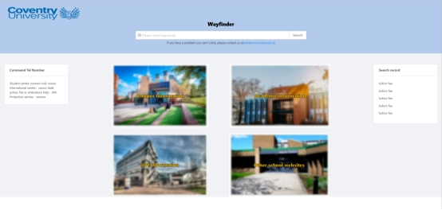

**Function page**

I set four functional pages in the website for academic/school/life/other website information. Each function page has five pieces of information associated with it. At the same time, to reserve the information that may be added later, I preset the page jump bar. On the left side of the function page, the option to jump directly to the other three plates is set so that users can quickly jump to the function

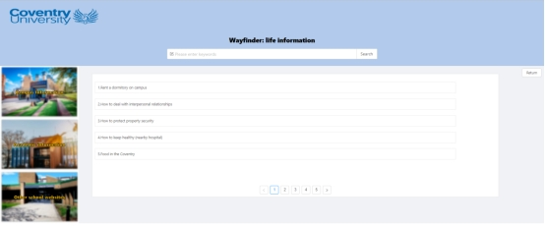

**Tuition inquiry preparation page**

In the tuition fee inquiry preparation page, I set three pre-selected items for the conditions of the tuition inquiry. This can better humanize the user according to their situation, give the user autonomy to choose the corresponding tuition restrictions, avoid too many conditions appearing in the database, and make it convenient for users to extract information. Also, several features on the page -- for example, pop-ups prompt users if they have yet to select options thoroughly.

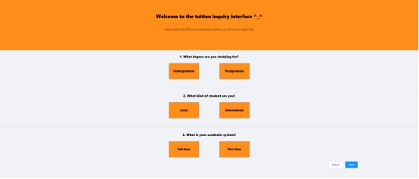

**Tuition inquiry interface**

In the tuition inquiry interface, users can choose their own course major according to their own discipline. At the same time, the user can enter the discipline name and discipline code in the search box to search at the same time. In the tuition displayed on the page, the user can know the specific information of the major -- such as the year/grade of enrollment, etc., to conduct a tuition review. At the same time, if the user chooses wrong on the tuition preparation query page, he can also return to the preparation page to modify the information screening items.

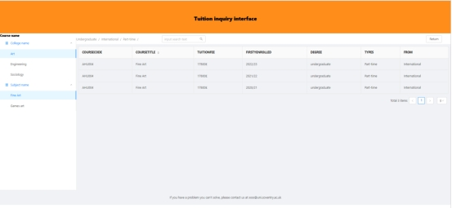

# Chapter Ⅷ: Conclusion

In this project, to improve the experience of Chinese students in higher education in the UK, Chinese students are taken as research objects and UX design methods are used. Improving and reworking Coventry University's Wayfinder website - The Wayfinder website is Coventry University's commitment to providing high-quality information to students. In this project, the results obtained from the survey on the use of websites by international students in China are discussed, and the data obtained from the results are analyzed. Based on the results of the data analysis, the UI/ function of the home page of Wayfinder is redesigned, and the operation process of querying tuition is optimized. According to the data, the interactive prototype files of the Wayfinder website and the code implementation of actual web pages are made. This project's results have effectively improved Chinese students' experience using Wayfinder Web pages.

In the process of this project, the main innovation points and contributions are as follows:

* This project is the first one in the UK to focus on the information query needs and experience research of Chinese international students in higher education in the UK from the perspective of UX design, filling the gap in related fields.
* This project is an improvement case of the Wayfinder website based on User-centered Design (UCD). According to the particularity/special needs of Chinese students, it breaks through the problems existing in the existing website, emphasizes the requirements, preferences and satisfaction of Chinese international students, and effectively improves the sense of the experience of Chinese international students using Wayfinder.
* This project uses a variety of user survey methods -- visit/interview/questionnaire survey, which effectively ensures the reliability and validity of this study. And it provides valuable reference data for future related research.

Although this project has effectively improved the experience of Chinese students using Wayfinder, there are still some deficiencies and parts worth exploring, which are worth further improvement and perfection:

* The improvement scheme of the design in this project needs to be verified in more user scenarios and situations. For example, in the user survey, most interviewees are junior students, so the specific data and opinions in the interview have certain limitations. There is no better comprehensive coverage of the opinions and needs of students in all grades.
* More in-depth information investigation is needed to implement program application in this project. For example, on the home page of the web page, although the division consists of multiple information modules, the information in the modules does not carry out more investigation on this, so the specific content of the relevant information cannot be designed, such as the information related to the school academic (academic deferment, etc.). Secondly, in redesigning the tuition query, due to the need for more accurate/specific information about the school's tuition, it cannot bring users a complete user experience.

Based on the results of this project, future research projects can be carried out in the following directions:

* Explore more ways suitable for British universities to use UX design to help Chinese international students improve the experience of learning and living in the UK to meet the needs and characteristics of different situations and users.
* Further study and compare the methods used by higher education in different countries and regions to improve student information query websites by UX design, and summarize the similarities and differences, advantages and disadvantages, to provide a more valuable reference for more cross-cultural communication and cooperation.

# Chapter Ⅸ： Project Management

## Project aim and objectives

In this project, the main objective is to use UX design techniques to improve the experience of Chinese international students using the Coventry University Wayfinder website.

In this project, the main objectives are as follows.

1. Possibly valid data by conducting multiple

forms of surveys on the target users (Chinese international students in the UK).

2. Analyze the data from the user survey and explore the problems faced by Chinese international students in the UK.

3. Based on the analyzed data, make an interactive prototype - an improved Wayfinder website

4. Re-design the UI/ function of the Coventry University homepage and improve the process of querying tuition fees (if the survey results point to querying tuition fees -- user improvement needs)

5. Compile a research report by summarizing and summarizing the research process.

## Current project completion

Based on the goal setting of the project, I completed all the work in full accordance with the preset goal. Here's what I got done:

1. User survey: In this project, Wayfinder is investigated among Chinese international students in the UK from a multi-dimensional perspective using an interview/questionnaire survey. According to the way of questionnaire interview, the students who left their contact information in the questionnaire were interviewed -- based on the questions in the questionnaire, a more in-depth investigation was carried out, and practical suggestions were obtained.

2. Data analysis: In the questionnaire interview, according to the data obtained, data visualization such as bar chart/pie chart was carried out, and the values were compared, and the recent experience of Chinese international students in using the Wayfinder website and the parts of Wayfinder website facing/worth improving were obtained. In the interviews with the users, their opinions and suggestions on the Wayfinder website were learned, and the scenarios where the problems occurred were understood.

3. Prototype design: The interactive design prototype diagram was made through the analysis of the data. The home page of Wayfinder is redesigned, and the process of inquiring about tuition is improved.

4. Code implementation: Through the prototype design diagram, all the functions and UI design can be successfully run in the code implementation.

5. Research report: Through the process of this project, the research report was written.

## 3. The technologies and tools involved in the project

In the flow of the current project, there are many technologies and software involved. Here's what techniques I used.

1. Questionnaire survey --sojump questionnaire platform (software)/text questionnaire (single choice/multiple choice/short answer)

2. Interview - Face-to-face interview

3. Prototyping - Just-in-time design (software) /Ant Desing elements

4. Code implementation - Java (language)/Vue framework (front-end) /HTML+CSS+JavaScript/ Spring boots framework (back-end)/MySQL (database) /Ant design Vue (partial ICONS)

## 4. Project Planning

The life cycle of this project for 56 days, the start time for February 3, 2023. The end date is March 31, 2023

Here's a Gantt chart for my work:

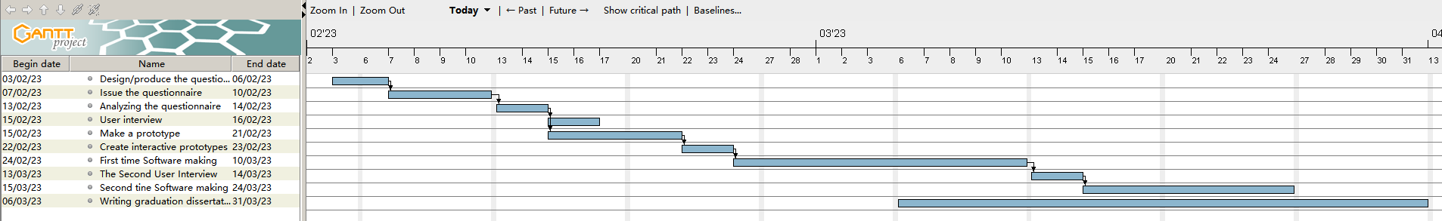

Specific working time plan:

Specific working time plan:

1. 03/02/23 -- 06/02/23: Design the questionnaire

Based on the previous interview (a long period of time), questionnaire questions were made in order to explore users' experience and feelings on Wayfinder.

2.07/02/23 -- 10/02/23: Release questionnaires

After completing the survey, publish the Google form. However, considering that the target of the investigation was Chinese international students, I switched to Sojump platform immediately. And started collecting data.

3.13/02/23 -- 14/02/23: Analyze questionnaire data

Using the user feedback data, the analytics tools on Sojump are used to compile what Wayfinder currently needs to change most.

4.15/02/23 -- 16/02/23: First user interview

The survey is about the users who fill in the personal information in the questionnaire, and based on the answers of the users' questionnaires, we will have a deeper understanding.

5.15/02/23 -- 21/02/23: Prototyping

According to the results of the investigation and analysis, prototype design/drawing of the target web page.

6.22/02/23 -- 23/02/23 : Make interactive prototypes

After discussion with the tutor, I decided to make interactive prototype.

7.24/02/23 -- 23/03/23: First website production

According to the prototype design, construct the Wayfinder website.

8.13/03/23 -- 14/03/23: Second user interview

After the construction of the prototype website is completed, the second interview is conducted with the users and opinions on modification are obtained.

9.15/03/23 -- 04/03/23: Second website production

Through the second user feedback results, to improve the existing website.

10.06/03/23 -- 31/03/23: Writing the graduation report

Write reports as the project progresses.

## 5. Meetings with supervisors and evidence of supervision

In this semester, I had six meetings with my supervisor Professor John Halloran and attended all of them. There was one group meeting and five individual meetings. The dates are 30 January / 7 February, 21 March 7, 21 April 4 2023.

Below is a list of what was discussed with the supervisor at each meeting and what feedback was given

January 30 meeting -- Plenary

Content: In the meeting, the director announced the information about the project and some requirements about the structure of the report, and conducted the Q&A questions. During the project, I asked for specific information about the project's report content/submission time, etc.

Reaction: After this report, I began to formulate the idea of the project and prepare the questionnaire.

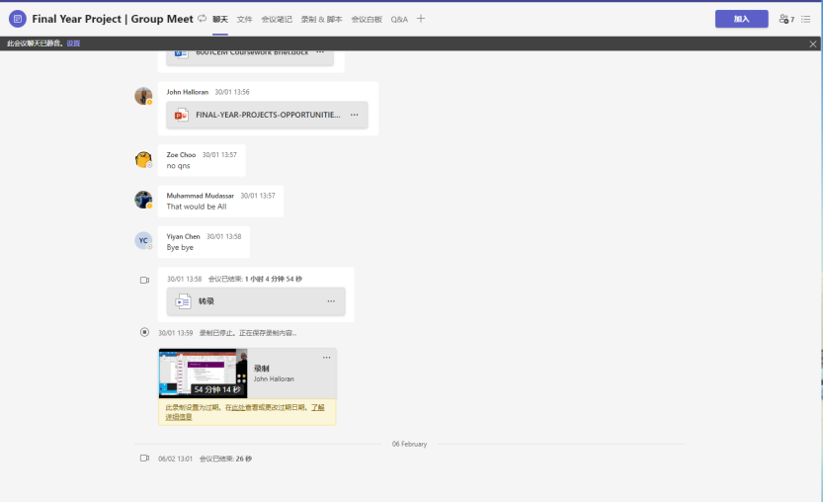

(evidence screenshot for meeting )

February 7 Meeting -- Personal

Content: In the meeting, I talked about the topic part of my questionnaire survey and got the guidance from the supervisor. I also asked questions about future project plans.

Reaction: After the meeting, I read the information provided by the supervisor and modified the questionnaire report to some extent.

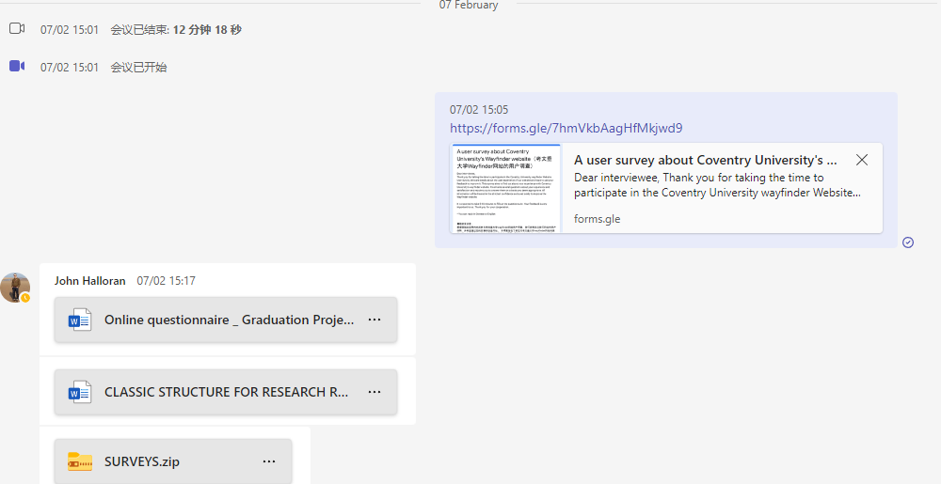

(evidence screenshot for meeting )

Feb. 21 -- Personal

Content:

Presented my Wayfinder prototype design and communicated about the timing of the project. The supervisor proposed the need for interactive prototyping and proposed the project schedule requirements.

Reaction:

After the meeting, I revised the prototype and implemented the interactive prototype. And rescheduled the project planning time.

(evidence link: [yisong project supervision-20230221\_150049-会议记录.mp4](https://livecoventryac-my.sharepoint.com/:v:/r/personal/liy332_uni_coventry_ac_uk/Documents/Final%20project%20related%20materials%20and%20evidence/Recordings%20With%20Supervisor/yisong%20project%20supervision-20230221_150049-%E4%BC%9A%E8%AE%AE%E8%AE%B0%E5%BD%95.mp4?csf=1&web=1&e=m4BVZi))

March 7 -- Personal

Content:

In the meeting, the general content of the website made for the first time was shown, and the content of the first user visit after sorting was shown. In addition, the user results of the questionnaire were presented and discussed with the supervisor. My supervisor commented on these tasks and gave me advice on perfecting the prototype. Questions about project details and reporting are also discussed

Reaction:

Based on the feedback from the tutor, I improved the prototype design and continued to complete the project.

(evidence link: [yisong project supervision-20230307\_145958-会议记录.mp4](https://livecoventryac-my.sharepoint.com/:v:/r/personal/liy332_uni_coventry_ac_uk/Documents/Final%20project%20related%20materials%20and%20evidence/Recordings%20With%20Supervisor/yisong%20project%20supervision-20230307_145958-%E4%BC%9A%E8%AE%AE%E8%AE%B0%E5%BD%95.mp4?csf=1&web=1&e=0Zlita))

March 21 -- Personal

Content:

In this project, the supervisor and I checked the progress of the technology/user learning/report implementation used in the project and showed the components related to it. And communicated the detailed information of the report to the supervisor.

Reaction:

According to the supervisor suggestions, continue to prepare the report

(evidence links: [yisong project meet-20230321\_150019-会议记录.mp4](https://livecoventryac-my.sharepoint.com/:v:/r/personal/liy332_uni_coventry_ac_uk/Documents/Final%20project%20related%20materials%20and%20evidence/Recordings%20With%20Supervisor/yisong%20project%20meet-20230321_150019-%E4%BC%9A%E8%AE%AE%E8%AE%B0%E5%BD%95.mp4?csf=1&web=1&e=EdCZDH))

March 29 -- Personal

Content:

I checked my report with my supervisor, who gave me feedback and modified my report.

Reaction: Continuously revise the report

(evidence link：[yisong project meet-20230329\_150142-会议记录.mp4](https://livecoventryac-my.sharepoint.com/:v:/r/personal/liy332_uni_coventry_ac_uk/Documents/Final%20project%20related%20materials%20and%20evidence/Recordings%20With%20Supervisor/yisong%20project%20meet-20230329_150142-%E4%BC%9A%E8%AE%AE%E8%AE%B0%E5%BD%95.mp4?csf=1&web=1&e=2guKMV))

April 4

Content:

In this meeting, the two parts of the paper, literature review and methodology, were carefully explored with the supervisor, and it was found that the number of words in the literature review was too large and there was logic ambiguity, and the content of the methodology part had not been discussed. The supervisor informed the following time and task arrangement, provided two regular supervisor feedback times, and confirmed the submission time and related submission rules.

Reaction:

After the meeting, I revised my article more carefully and rethought how to better organize the content of the two parts based on the suggestions provided by my tutor. And the content related to the project is summarized and submitted to the platform for management.

(evidence link: [yisong project meet-20230404\_150109-会议记录.mp4](https://livecoventryac-my.sharepoint.com/:v:/r/personal/liy332_uni_coventry_ac_uk/Documents/Final%20project%20related%20materials%20and%20evidence/Recordings%20With%20Supervisor/yisong%20project%20meet-20230404_150109-%E4%BC%9A%E8%AE%AE%E8%AE%B0%E5%BD%95.mp4?csf=1&web=1&e=JESMVN))

## 6. Evidence of the content of my project

* The code is available on Github:

Front End: <https://github.coventry.ac.uk/liy332/Final_Project_ForntEnd_Yisong_Li.git>

Back End: <https://github.coventry.ac.uk/liy332/Final_Project_BackEnd_Yisong_Li.git>

* Original questionnaire document:

[The questionnaire surveys the original data](https://livecoventryac-my.sharepoint.com/:f:/g/personal/liy332_uni_coventry_ac_uk/ErBlGOXlh3BJkJqqkhnHf6kBEkP3KyL0OKxkUkAFGViPJA?e=q7kHl5)

* Prototype drawing design file and video show the interaction:

[A prototype of Wayfinder](https://livecoventryac-my.sharepoint.com/:f:/g/personal/liy332_uni_coventry_ac_uk/EgoJtfJZMMpFto-XHDa8s9cBX0hx7pfJVPxM9okBENLqtA?e=vxCLR9)

* Video evidence with the supervisor meeting:

[Recordings With Supervisor](https://livecoventryac-my.sharepoint.com/:f:/g/personal/liy332_uni_coventry_ac_uk/EgnulvGuHM1Ci65KlDX2sXQBc70csNX0zeQbdiTBvgVwTg?e=Qr9UKc)

* Chat file of the meeting with the supervisor meeting:

[Chat notes of meetings with supervisors](https://livecoventryac-my.sharepoint.com/:f:/g/personal/liy332_uni_coventry_ac_uk/EjO_KKCp0ixLt5FOcssJtB8BbfFR7C8KBUszrDYHtKwOnw?e=s4KKF6)

* Documents were collated based on the first interview with the user of the questionnaire:

[First face-to-face interview with the user (recording conversation documents)](https://livecoventryac-my.sharepoint.com/:f:/g/personal/liy332_uni_coventry_ac_uk/EvsJkybUn3pAmAcKGvgukHEB_v2-I3pxHoBegaXbsRgzig?e=WLM7Q0)

* Telephone recording of the second interview with the user as evidenced:

[Second telephone interview evidence](https://livecoventryac-my.sharepoint.com/:f:/g/personal/liy332_uni_coventry_ac_uk/EvMg3L3QB4hGugINMRKwrXQBSZz3ST4cN3B7NppLQG3uUA?e=ucnvuw)

* Software operation demonstration:

[Program running video](https://livecoventryac-my.sharepoint.com/:f:/g/personal/liy332_uni_coventry_ac_uk/Ery_aWyL2whBgRGgSIDbK6IB-9H4mdEmv7HhH-p6T131tA?e=OViUZF)

* PPT about graduation project:

[Power point for final program](https://livecoventryac-my.sharepoint.com/:f:/g/personal/liy332_uni_coventry_ac_uk/EtlMSTaj2-hLt-7RAs87w0EB3jtI_MTqlEWzcG83mq8SCA?e=v7aGXo)

## 7. The project explores social, professional, legal and ethical issues

UX design is used in this project. The goal is to improve the experience of Chinese international students using Coventry University Wayfinder, so as to enhance the experience of Chinese international students. At the same time, in this project, also involved in many aspects of the problem. Next, I will discuss the project from three aspects: social, professional, legal and ethical discussion.

**Social Issues:**

The main aim of the project is to increase the use of Coventry University Wayfinder by Chinese students studying abroad. In the process of user survey, in order to better obtain the information users want, I conducted a user survey in a variety of ways. Considering the poor oral English of Chinese students, I communicate with them in Mandarin and let them express their real thoughts. So consider their needs when designing your web page. Secondly, although the design aims to change the Wayfinder experience of Chinese international students, many problems encountered by Chinese international students were also found in the investigation part of the project -- for example, it is difficult to integrate local communities and the connection with the school is not strong. The data found in this research will also support future staff in improving the experience of Chinese international students in the UK, so as to better understand Chinese students and carry out better work.

Moreover, although this project aims to improve the Wayfinder experience for international students in China, the Wayfinder website of Coventry University is open to all students of Coventry University. Every student can have a better experience through Wayfinder, so I fully meet their needs. For example, in questionnaires, many Chinese students are not interested in "life information". But since the site is for all users, I've added a section dedicated to lifestyle information. Secondly, as Coventry University is open to people of different genders from all over the world, I try to avoid design elements and content that are discriminatory, biased or offensive.

**Professional Issue：**

UX design was used in this project, and the design principle of UX design -- "user-centered" was fully adhered to. In the design, I made full use of various techniques. For example, I have better-understood users' needs through different survey methods in the user survey. In data analysis, I used a variety of icon types to conduct multi-directional research of the data. In the prototype design, I used interactive prototyping to display the website's function better. In the code implementation, I use the language of the current popular software development tools to match the realistic factors for development better. Secondly, I respected Coventry University Wayfinder's function and visual style, tried to match the existing Wayfinder website in colour selection and function retention, and retained elements of Coventry University in Wayfinder. For example, the background behind each board is the building of Coventry University.

**Legal and ethical issues：**

In this project, a variety of cultures/languages and backgrounds are designed, and many places involve the personal information and privacy of many users. On the legal side, the EU's General Data Protection Framework (GDPR) will ensure that the information and data used in surveys and interviews are properly used - for example, the data will be stored locally. And in all surveys, users' feedback is used with their consent. Secondly, the elements and technologies involved in prototype design and software development are all third-party open-source software and the means of obtaining them are all official sources.

Regarding ethics, although the interviewees are all Chinese students, I still respect their differences and diversity and respect everyone's ideas. In addition, during the interview, I kept an open and neutral position, did not ask interviewees to answer questions with subjective intentions or misleading language, and did not modify data or judge others' answers based on personal judgment. There is no political/racial bias in the development of web pages, only responsible design of prototypes and software that meet the needs and expectations of users.

## 8. Project risk management

Although the project progressed smoothly, and I completed the project according to the preset target, I still encountered some problems in the project process. The following will list the issues that occurred in the project and my solutions.

1. Transformation of project programming ideas and techniques

Reason: I used Flask framework /Python as the primary language in developing the website for the preset project technology selection. However, according to the actual progress of the project, it is found that the development time of the existing project needs to be increased. Because Flask is only a microframework, which only provides some core functions, and some functions need to be written by ourselves. This will lead to increased difficulty in the project's development and can not be guaranteed to be completed within the expected schedule.

Solution: After re-evaluating the technology, Vue+Spring boot was selected as the development framework /Java as the primary language. The advantage is that it can be more easily developed, and it will be more convenient to realize some functions. And I have experience developing with a combination of these technologies, which makes the development process much smoother.

2. Software changes of prototype design drawing

Reason: I planned to use Adobe XD to design the prototype in the project presets. However, due to license issues, Adobe XD cannot be used legally.

Solution: After finding this problem, I communicated with my tutor in time and used the alternative software "Instant Design", a Chinese UI/UX design software, and successfully drew an interactive prototype.

3. Change of questionnaire platform

Question: In the original plan, Google Forms was planned to be used as the publishing platform for the questionnaire questions in the user survey. However, Chinese international students rarely have the habit of using Google Forms.

Solution: According to the survey of social media commonly used by Chinese students, I used the "sojump" questionnaire platform widely used by Chinese students as the questionnaire release platform, which effectively improved the feedback efficiency of the questionnaire.

## 9. The future work of my project

So far, all my graduation projects have been completed. However, due to time constraints and a need for more information, it is still possible to continue the project in the future.

In this project, to improve the Wayfinder design, through data investigation, I comprehensively chose to enhance the home page layout and improve the tuition inquiry function as the tasks of this project. However, through the feedback from the questionnaire survey, there are still many functions worth improving, such as inquiring about academic information. Moreover, through this project, I also realized that there is a need to improve cross-cultural communication on many websites of the school at present. Therefore, I can work to enhance students' experience in different regions through this project experience in the future.

## 10. Power Point screenshot:

**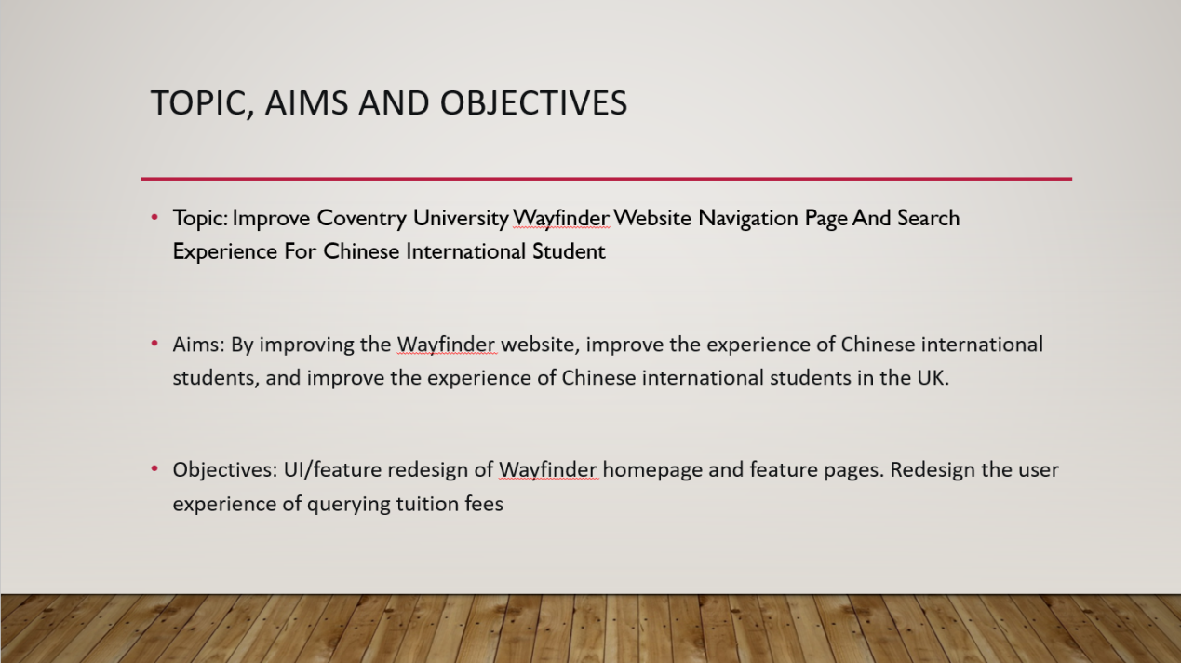**

**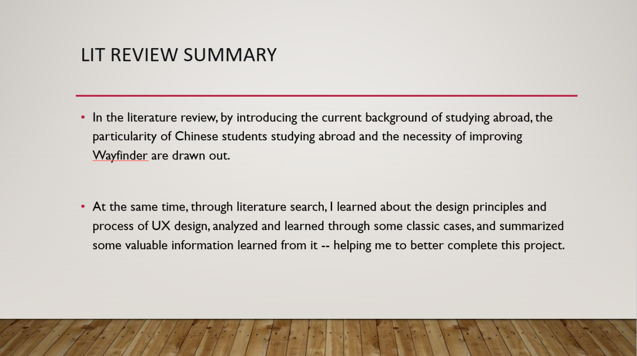**

**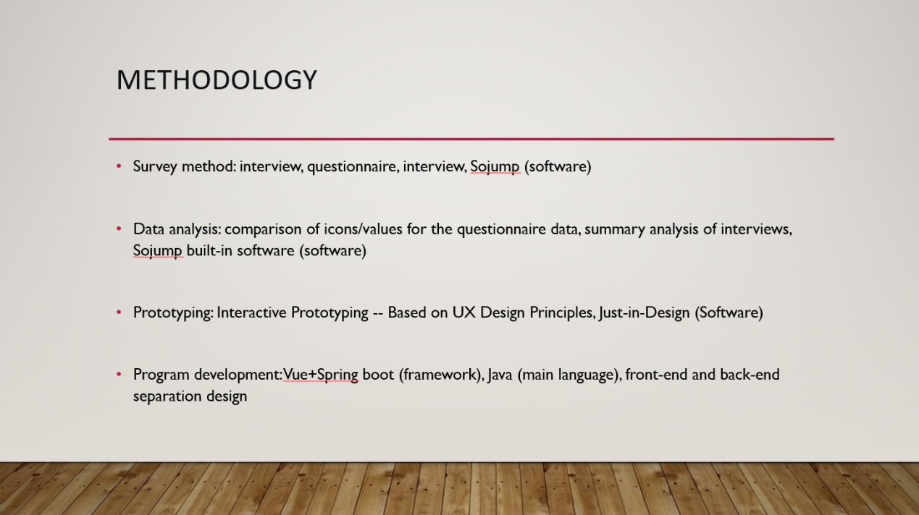**

**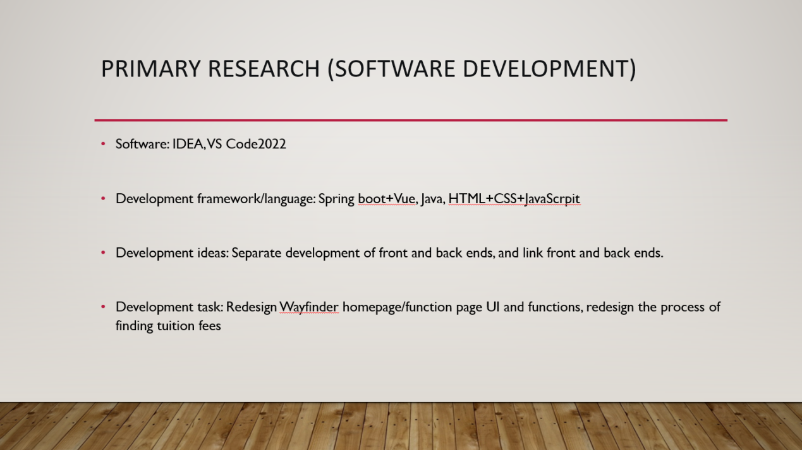**

**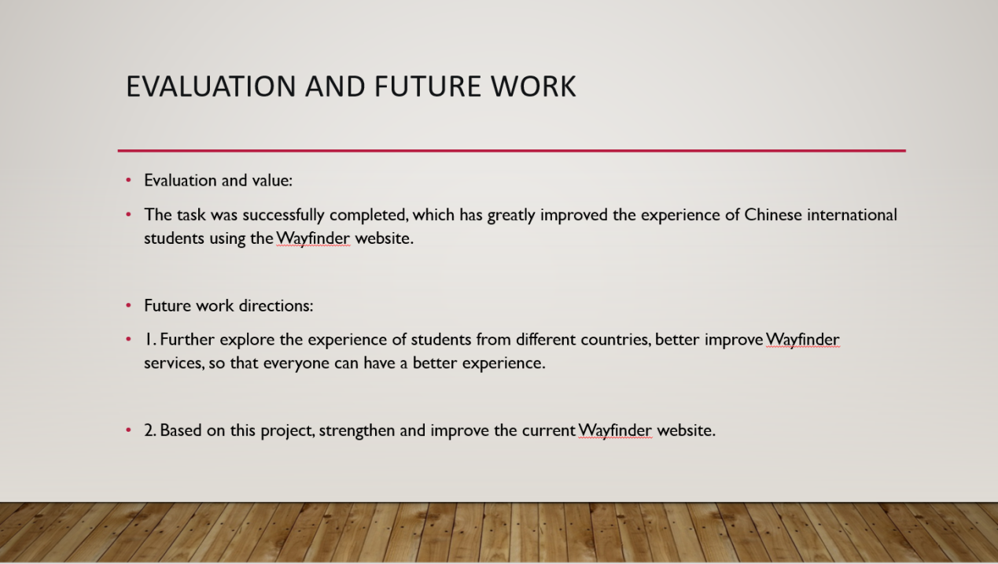**

# Chapter Ⅹ: Acknowledgement

First, I would like to thank my supervisor, Dr John Hallorand, for his support and instruction for my graduation project, which enabled me to complete this task successfully. Here, I would like to express my heartfelt thanks.

As an exchange student from China, I am fortunate to embark on my first study trip in a foreign country. Therefore, I would like to thank my family; with their support, I can enjoy a high-quality education. Thank you for everything Mom and Dad have done for me so that I can chase my dreams.

The past two years of pursuing my dream in the UK have been full of significant challenges for me. However, during my two years at Coventry University, numerous excellent teachers and classmates gave me a lot of guidance and advice in academics and life. In addition, I would like to give special thanks to my first foreign friend, Mr Andrey Enescu, whose psychological support and companionship made me feel at home during my two years in a foreign land.

In addition, I would like to thank my good friends in the UK, Especially Miss Mingfei Liu, thank you for getting to know and accompanying you; thank you for your support along the way; it is because of you that I am able to become what I am today. I would also like to sincerely thank my good friends in China, especially Mr Lin He and Miss Xin Zhou. Thank you for being there for me.

Since coming to the UK in 2021, I have grown a lot through what I have experienced and seen. For that, I also want to thank myself. Thank you, perseverance and indomitable spirit; go forward, overcome difficulties, come today, and realize your dreams. As the ancients said: "Steed leap, not ten steps; Ten o nags ride, but never give up.". Thanks to my efforts in the past two years, I have become more mature and robust.

Finally, I want to thank everyone I've met on this journey for supporting my choices. There is a long road ahead. I will continue to pursue my dream. I will not stop at the pace of pursuing my dream.

# Chapter Ⅺ: Reference

1.Admin, E. (2022). UK international student statistics 2022. [https://erudera.com/statistics/uk/uk-international-student-statistics/](https://erudera.com/statistics/uk/uk-international-student-statistics/" \t "_blank)

2.Almeida, F., & Monteiro, J. A. (2017). Approaches and principles for UX web experiences: A case study approach. International Journal of Information Technology and Web Engineering (IJITWE), 12(2), 49-65.

3.Ammigan, R., & Jones, E. (2018). Improving the student experience: Learning from a comparative study of international student satisfaction. Journal of Studies in International Education, 22(4), 283-301.

4.Ant design. [https://ant.design/index-cn](https://ant.design/index-cn" \t "_blank)

5.Apple’s website: Comprehensive analysis of the UX design with heatmaps. (2021, -02-19T11:38:10+00:00). [https://capturly.com/blog/apples-website-comprehensive-analysis-of-the-ux-design-with-heatmaps/](https://capturly.com/blog/apples-website-comprehensive-analysis-of-the-ux-design-with-heatmaps/" \t "_blank)

6.Bertram, D. M., Poulakis, M., Elsasser, B. S., & Kumar, E. (2014). Social support and acculturation in chinese international students. Journal of Multicultural Counseling and Development, 42(2), 107-124.

7.Blue and white color matching, very simple and easy to use. (2021). [www.sohu.com/a/483215811\_120048041](https://refworks.proquest.com/www.sohu.com/a/483215811_120048041" \t "_blank)

8.Boomtime forecast for chinese applicants to UK HE by 2030. (2022). [https://www.universityworldnews.com/post.php?story=2022031812272290](https://www.universityworldnews.com/post.php?story=2022031812272290" \t "_blank)

9.China Youth Daily. (2016). The differences between chinese and western classrooms are artificially opposed. good education has no essential difference. [http://www.xinhuanet.com/politics/2016-06/06/c\_129042128.htm](http://www.xinhuanet.com/politics/2016-06/06/c_129042128.htm" \t "_blank)

10.Counsell, D. (2011). Chinese students abroad: Why they choose the UK and how they see their future. China: An International Journal, 9(01), 48-71.

11.Coventry university UK | ranking, courses and scholarships. (2023). [https://www.studyin-uk.com/profiles/university/coventry/](https://www.studyin-uk.com/profiles/university/coventry/" \t "_blank)

12.Cynical Gary. (2020, 22 Feb,). Advantages of SpringBoot technology. [https://www.cnblogs.com/1138720556Gary/p/12347969.html](https://www.cnblogs.com/1138720556Gary/p/12347969.html" \t "_blank)

13.Designer-approved website color schemes. [https://www.canva.com/learn/website-color-schemes/](https://www.canva.com/learn/website-color-schemes/" \t "_blank)

14.Differences between vue and react. (2022). [https://worktile.com/kb/ask/19606.html](https://worktile.com/kb/ask/19606.html" \t "_blank)

15.Educations. (2023). Top 10 places in the world to study abroad - 2023. [https://www.educations.com/top-10-lists/top-10-places-to-study-abroad-global-18096](https://www.educations.com/top-10-lists/top-10-places-to-study-abroad-global-18096" \t "_blank)

16.Erdős, F. (2019). (2019). Economical aspects of UX design and development. Paper presented at the 2019 10th IEEE International Conference on Cognitive Infocommunications (CogInfoCom), 211-214.

173.Fleming, J., & Koman, R. (1998). Web navigation: Designing the user experience. O'reilly Sebastopol, CA.

18.Forbetterworld. (2018, Feb 1,). Summary of user experience research methods. [http://forbetterworld.cn/%e7%94%a8%e6%88%b7%e4%bd%93%e9%aa%8c%e7%a0%94%e7%a9%b6%e6%96%b9%e6%b3%95%e6%80%bb%e7%bb%93/](http://forbetterworld.cn/%e7%94%a8%e6%88%b7%e4%bd%93%e9%aa%8c%e7%a0%94%e7%a9%b6%e6%96%b9%e6%b3%95%e6%80%bb%e7%bb%93/" \t "_blank)

19.Gaster, A. (2021, -05-25T16:15:35-03:00). Perfect UX writing: AirBnB 2021 UX upgrades example | dorve. [https://dorve.com/blog/ux/ux-writing-airbnb-ux-upgrades-perfect-way/](https://dorve.com/blog/ux/ux-writing-airbnb-ux-upgrades-perfect-way/" \t "_blank)

20.Gray, C. M. (2016). (2016). " It's more of a mindset than a method" UX practitioners' conception of design methods. Paper presented at the Proceedings of the 2016 CHI Conference on Human Factors in Computing Systems, 4044-4055.

21.Higher education student statistics: UK, 2020/21 - where students come from and go to study | HESA. (2022). [https://www.hesa.ac.uk/news/25-01-2022/sb262-higher-education-student-statistics/location](https://www.hesa.ac.uk/news/25-01-2022/sb262-higher-education-student-statistics/location" \t "_blank)

22.Hokkanen, L., & Väänänen-Vainio-Mattila, K. (2015). (2015). UX work in startups: Current practices and future needs. Paper presented at the Agile Processes in Software Engineering and Extreme Programming: 16th International Conference, XP 2015, Helsinki, Finland, may 25-29, 2015, Proceedings 16, 81-92.

23.Hongyang Wang. (2016). From the front end, what is web design based on functionality. [http://maleskine-production:30000/p/400d0d0866cb](http://maleskine-production:30000/p/400d0d0866cb" \t "_blank)

24.How to benefit from color psychology in your website design. [https://www.trajectorywebdesign.com/blog/web-design-color-psychology/](https://www.trajectorywebdesign.com/blog/web-design-color-psychology/" \t "_blank)

25.How to understand that conventions in SpringBoot are better than configuration. (2019). [https://cloud.tencent.com/developer/article/1424634](https://cloud.tencent.com/developer/article/1424634" \t "_blank)

26.International student | imperial college london. [https://www.imperial.ac.uk/study/international-students/](https://www.imperial.ac.uk/study/international-students/" \t "_blank)

27.Kollmann, J., Sharp, H., & Blandford, A. (2009). (2009). The importance of identity and vision to user experience designers on agile projects. Paper presented at the 2009 Agile Conference, 11-18.

28.Konstantakis, M., & Caridakis, G. (2020). Adding culture to UX: UX research methodologies and applications in cultural heritage. Journal on Computing and Cultural Heritage (JOCCH), 13(1), 1-17.

29.KostyaStepanov. (2020). 9 filtering design best practices to improve E-commerce UX. [https://uxplanet.org/9-filtering-design-best-practices-to-improve-e-commerce-ux-edac50560f94](https://uxplanet.org/9-filtering-design-best-practices-to-improve-e-commerce-ux-edac50560f94" \t "_blank)

30.Levlin, M. (2020). DOM benchmark comparison of the front-end JavaScript frameworks react, angular, vue, and svelte.

31.Li, X., & Chen, W. (2014). Facebook or renren? A comparative study of social networking site use and social capital among chinese international students in the united states. Computers in Human Behavior, 35, 116-123.

32.NagasakiAtomicBomb. (2020). Spring boot framework (1) - introduction, advantages and disadvantages of spring boot. [https://blog.csdn.net/baidu\_27414099/article/details/105425112](https://blog.csdn.net/baidu_27414099/article/details/105425112" \t "_blank)

33.Nielsen, J. (1995). How to conduct a heuristic evaluation. Nielsen Norman Group, 1(1), 8.

34.Pages - returning and new student fees for academic year 2022/23. [https://share.coventry.ac.uk/students/Finance/Pages/Student-Fees.aspx](https://share.coventry.ac.uk/students/Finance/Pages/Student-Fees.aspx" \t "_blank)

35.Petrie, H., & Power, C. (2012). (2012). What do users really care about? A comparison of usability problems found by users and experts on highly interactive websites. Paper presented at the Proceedings of the SIGCHI Conference on Human Factors in Computing Systems, 2107-2116.

36.Rawat, P., & Mahajan, A. N. (2020a). ReactJS: A modern web development framework. International Journal of Innovative Science and Research Technology, 5(11), 698-702.

37.Rawat, P., & Mahajan, A. N. (2020b). ReactJS: A modern web development framework. International Journal of Innovative Science and Research Technology, 5(11), 698-702.

38.Saks, E. (2019). JavaScript frameworks: Angular vs react vs vue.

39.Schweisfurth, M., & Gu, Q. (2009). Exploring the experiences of international students in UK higher education: Possibilities and limits of interculturality in university life. Intercultural Education, 20(5), 463-473.

40.Sclater, N. (2008). Large-scale open source e-learning systems at the open university UK. Research Bulletin, 2008(12), 1-13.

21.Setiyani, L., & Tjandra, E. (2022). UI/UX design model for student complaint handling application using design thinking method (case study: STMIK rosma karawang). International Journal of Science, Technology & Management, 3(3), 690-702.

42.Sherry, M., Thomas, P., & Chui, W. H. (2010). International students: A vulnerable student population. Higher Education, 60, 33-46.

43.Sojump. [https://www.wjx.cn/](https://www.wjx.cn/" \t "_blank)

44.Spring. (2020). [http://maleskine-production:30000/p/9bc39d86d9e1](http://maleskine-production:30000/p/9bc39d86d9e1" \t "_blank)

45.Success coaches -- coventry university. [https://www.coventry.ac.uk/study-at-coventry/student-support/success-coaches/](https://www.coventry.ac.uk/study-at-coventry/student-support/success-coaches/" \t "_blank)

46.Tognazzini, B. (2014, -03-06T01:38:02+00:00). First principles of interaction design (revised & expanded). [https://asktog.com/atc/principles-of-interaction-design/](https://asktog.com/atc/principles-of-interaction-design/" \t "_blank)

47.UCL international support team. (2018). International support. [https://www.ucl.ac.uk/students/international-students/international-support](https://www.ucl.ac.uk/students/international-students/international-support" \t "_blank)

48.What is net promoter score (NPS)? how to calculate & interpret. (2023). [https://www.hotjar.com/net-promoter-score/](https://www.hotjar.com/net-promoter-score/" \t "_blank)

49.What is the meaning of orange? [https://www.adobe.com/creativecloud/design/hub/guides/meaning-of-orange-in-design](https://www.adobe.com/creativecloud/design/hub/guides/meaning-of-orange-in-design" \t "_blank)

50.Yijiao Qi, & Qiong xie. (2018). Cross-cultural adaptability of overseas students based on cultural dimension theory: A case study of 77 chinese students who studied in germany for more than half a year. Journal of Beijing International Studies University, 40(5), 111.

51.YXPM. (2023, 20 mar,). Product technique and the way: The analysis of the law of interaction design 7 application | everyone is the product manager. [https://www.woshipm.com/ucd/5785070.html](https://www.woshipm.com/ucd/5785070.html" \t "_blank)